# IRM and MDTC Reports

There are a number of new reports, both in FAB / UI and Cognos BI, for monitoring MTDC, providing information to help with MTDC projections as well as some designed specifically to observe the impact of interim rate changes. This document describes the content and purpose of each report and provides typical selection criteria for running/viewing the report.

**The FAB / UI Reports which are available within the IR Projections Application include:**

IR Reports – IR MTDC Actuals Multi-Year Report *

IR Reports – IR Forecast Analysis Report *

**The Cognos BI Reports include:**

IRM Report #1 - MTDC Expenditures by Month - Running Total *

IRM Report #2 - MTDC Expenditures by Month - Monthly Increments *

IRM Report #3 - MTDC Total by Account- Including Interim Rate Impact *

IRM Report #4 - MTDC Total Entity and Rate Type – Including Interim Rate Impact

IRM Report #5 - MTDC Total by Entity and Lab – Including Interim Rate Impact

IRM Report #6 - MTDC Total by Entity and Fund Source – Including Interim Rate Impact

IRM Report #7 - MTDC Total by Entity and Normalized Fund Source – Including Interim Rate Impact

IRM Report #8 - Forecast Expense Report Summary by Expense Class Interim Planning Rates *

IRM Report #9 - Forecast Expense Report Summary by Account Interim Planning Rates *

* Reports may be most useful for Divisions and Programs:

The two FAB / UI reports include information by account key with the ability to total, group, filter and sort all account keys after creating a dimension filter for your Lab/Div/Prog.

The first three Cognos BI reports are by account key with the ability to further narrow down information by contract, fund source, rate type, subfacility, facility and division code.

The last two Cognos BI reports show how changes in interim rates might impact accounts, both at the account level (report #9) and expense class level (Report #8)

**Terminology / Definitions**

|  |
| --- |
| **IFAS Budget Current** - Uncommitted + Committed Carryover + New Funds + Transfers |
| **Incurred Actual EOM YTD** - Incurred Actual Expenses YTD as of Latest End of Month |
| **IR Incurred Actual EOM YTD** - Incurred Actual Expenses YTD at Interim Rate as of Latest End of Month |
| **Working Plan** - A centralized, calculated scenario for planning staff and non-salary expenses |
| **Working Plan Remaining** - Working Plan from latest End of Month forward |
| **Forecast** - Incurred Actual Expenses YTD as of Latest End of Month + Working Plan Remaining |
| **IR Working Plan** - Working Plan with Interim Rates Applied |
| **IR Working Plan Remaining** - Working Plan with Interim Rates Applied from latest End of Month forward |
| **IR Forecast** - Forecast at Interim Rate (IR Incurred Actual Expenses EOM YTD + IR Working Plan Remaining) |
| **Expected Funds** - Expected Funding not yet at UCAR |
| **IFAS Budget vs IR Forecast** - Difference between IFAS Budget and IR Forecast (IR Forecast Funds Available) |
| **IR Forecast vs Working Plan** - Difference Between IR Forecast and Working Plan |

**FAB / UI Date Entry - Reports in the IR Projections Application**

**FAB / UI PRODUCTION URL:** [**https://fatahoe.fanda.ucar.edu/fab/fab.aspx**](https://fatahoe.fanda.ucar.edu/fab/fab.aspx)

The FAB / UI reports are under the “IR Reports” tab in IR Projections FAB / UI Application:

*(Recall IR Projections is accessed from the Application tab.)*

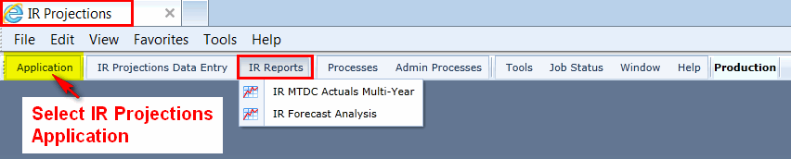

**FAB / UI IR Reports – IR MTDC Actuals Multi-Year Report**

**This report provides a historical look at MTDC by account key.**  It’s a “resaonableness” check that allows the user to make comparisons of projections for the current year to past years, taking into account differences and similarities of events in previous and the current years.

Within the UI, you have the ability to refine your information with totaling, grouping, filtering and sorting keys after creating a dimension filter for your Lab/Div/Prog.

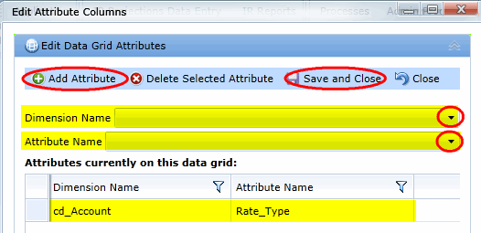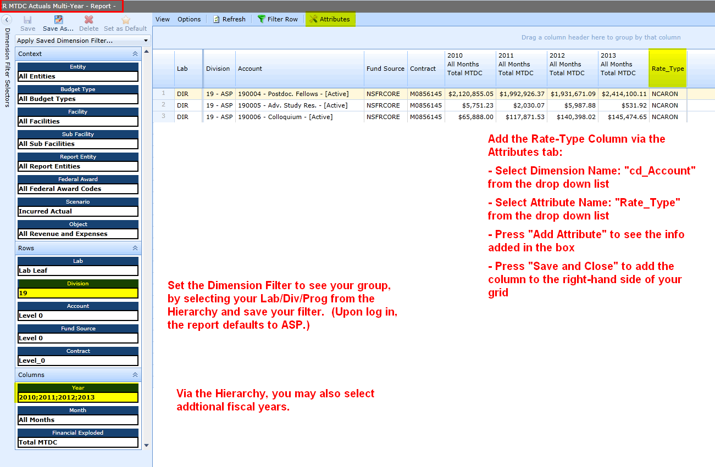

**FAB / UI IR Reports – IR Forecast Analysis Report**

This report provides a quick view of how accounts look with the interim rate applied. *(NOTE - when a report includes a forecast, actuals are as of the last month end and working plan remaining is from that month end forward. This is done to avoid double counting actuals as they occur during the next month but that were also within the current month’s working plan.)*

This begins with the IFAS Budget and applies interim rates to Incurred Actuals and Working Plan Remaining. The Forecast at interim rates is calculated from the IR Actuals and IR Working Plan. The IR Forecast Funds Available is shown via IFAS Budget less the IR Forecast expenses for the year.

Expected Budget is also provided in this grid to indicate expected funding not yet at UCAR. *(This information is added via the new Expected Budget – Plan Expected Funds by Month date entry grid.)*

Within the UI, you have the ability to refine your information with totaling, grouping, filtering and sorting keys after creating a dimension filter for your Lab /Div/ Prog.

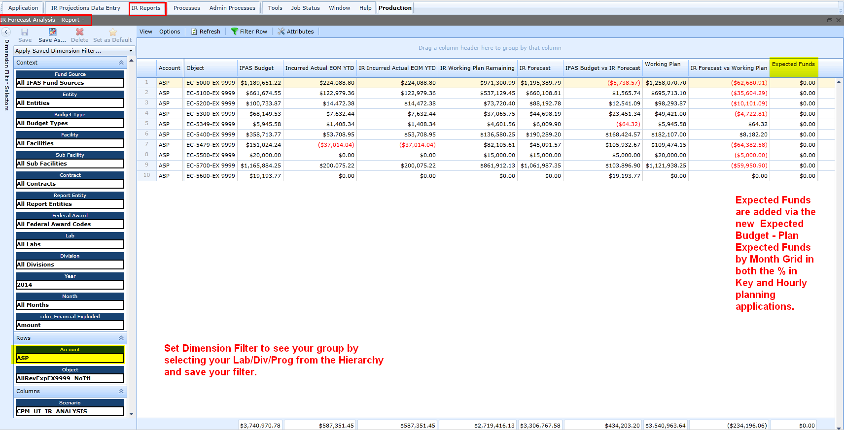

**Cognos BI Reporting Tool**

**Cognos BI PRODUCTION URL:** [**https://famead.fanda.ucar.edu/ibmcognos/**](https://famead.fanda.ucar.edu/ibmcognos/)

The Cognos BI reports are in: Public Folder > UCAR Reports > Adminstrative Reports > IRM.

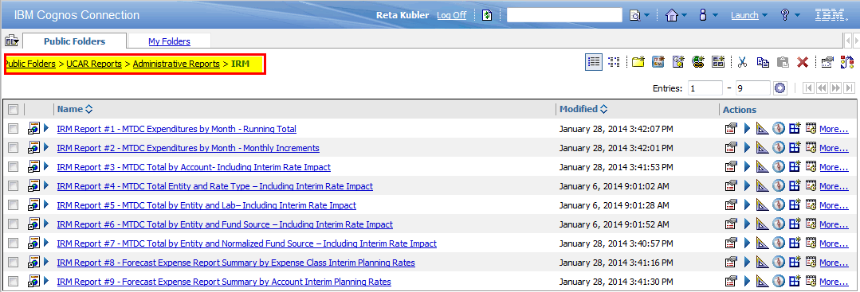

**IRM Report #1 - MTDC Expenditures by Month - Running Total**

**This report provides a RUNNING total of actual MTDC by month by account key for a given fiscal year.** *(In the example below, run prior to January month end, the December actual MTDC is also the running total for January and beyond… )* This report also provides paid days per month, highlighting months with 3 pay periods and the year end accrual impact of more paid days in September and fewer in October.

User prompts for running this report require fiscal year and one other selection. Typically users select information by “account starts with”, entity or lab, but can also select or narrow down by contract, fund source, rate type, subfacility, facility and division code.

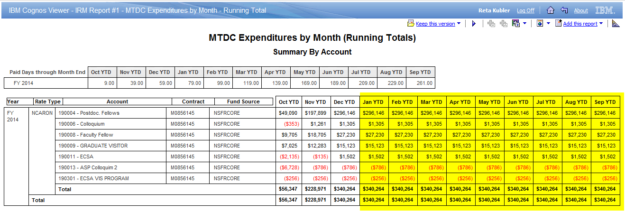

**IRM Report #2 - MTDC Expenditures by Month - Monthly Increments**

**This report provides a monthly INCREMENTAL total of actual MTDC by account key for a given fiscal year.** *(In the example below, run prior to January month end, there is information only for October, November and December.)* Again, the report also provides paid days per month, highlighting months with 3 pay periods and the year end accrual impact of more paid days in September and fewer in October.

User prompts for running this report require fiscal year and one other selection. Typically users select information by “account starts with”, entity or lab, but can also select or narrow down by contract, fund source, rate type, subfacility, facility and division code.

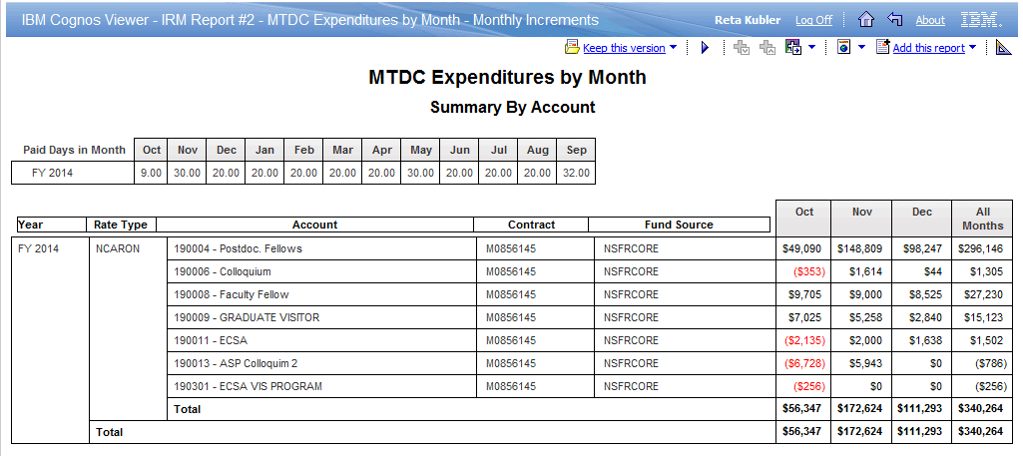

**IRM Report #3 - MTDC Total by Account- Including Interim Rate Impact**

**Should the interim Benefit Rate change, this report provides the user with information on the subsequent impact on MTDC by account key since benefit costs are included in MTDC .** *(In the example below, there has been no change in the interim benefit rate and therefore, no impact.)*

User prompts for running this report require fiscal year and one other selection. Typically users select information by “account starts with”, entity or lab, but can also select or narrow down by contract, fund source, rate type, subfacility, facility and division code.

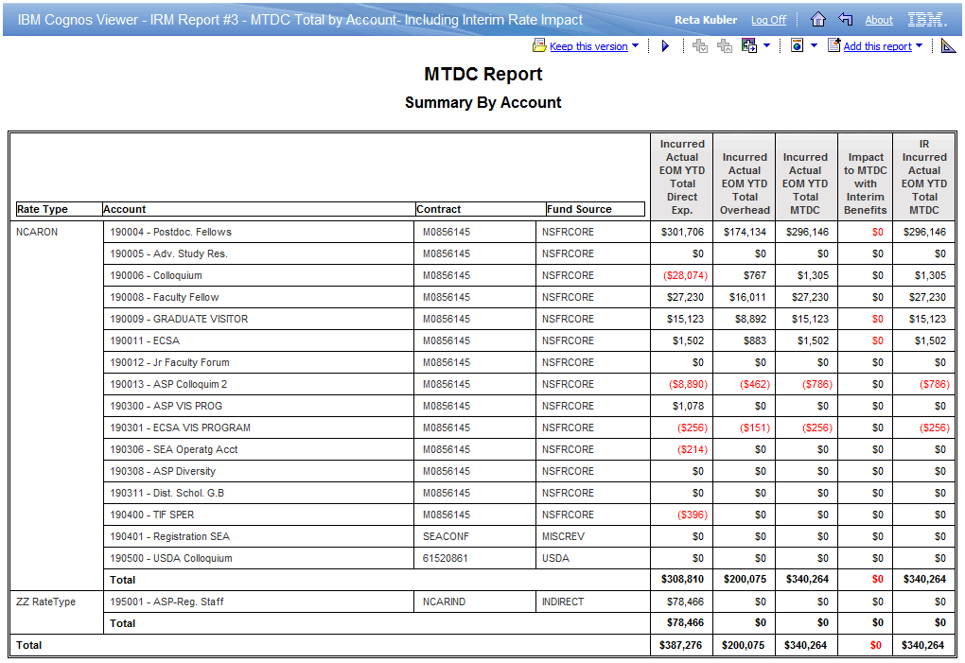

**IRM Report #4 - MTDC Total Entity and Rate Type – Including Interim Rate Impact**

**Should the interim Benefit Rate change, this report provides information at the entity and rate type level on the subsequent impact on MTDC as well as a forecast of how such a change might impact the overall MTDC estimate for the year.** The IR Forecast for MTDC includes interim benefit rates applied to actuals plus interim benefit rates applied to Working Plan Remaining. In the example below, there has been no change in the interim benefit rate and therefore, no impact. *(The example Accounts begin with “19” was continued; this report would typcally be run with the entity prompt rather than the account prompt.)*

User prompts for running this report require fiscal year and one other selection. Typically users select information entity, but can also select or narrow down by account, contract, fund source, and rate type.

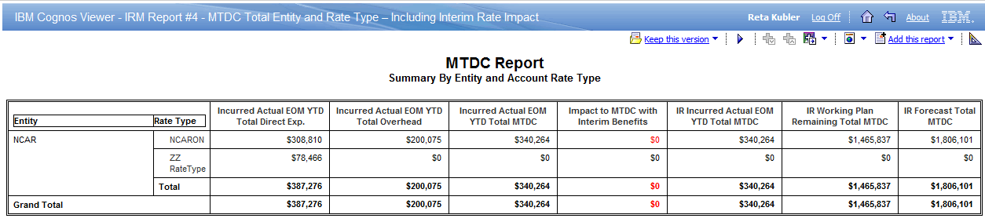

**IRM Report #5 - MTDC Total by Entity and Lab – Including Interim Rate Impact**

**This report provides information at the entity level, by lab and rate type, on the incurred actual MTDC at both provisional and interim rates as well as a forecast of how such a change might impact the overall MTDC estimate for the year.** The IR Forecast for MTDC includes interim benefit rates applied to actuals plus interim benefit rates applied to Working Plan Remaining. In the example below, there has been no change in the interim benefit rate and therefore, no impact. *(The example with Division “19” was continued; this report would typcally be run with the entity prompt rather than the account prompt.)*

User prompts for running this report require fiscal year and one other selection. Typically users select information entity, but can also select or narrow down by account, division code, contract, fund source, and rate type.

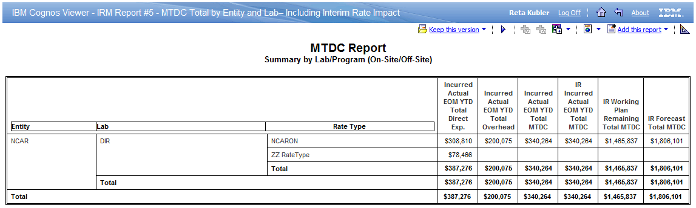

**IRM Report #6 - MTDC Total by Entity and Fund Source – Including Interim Rate Impact**

**This report provides information at the entity level, by rate type and fund source, on the impact of an interim Benefit Rate change on MTDC as well as a forecast of how such a change might impact the overall MTDC estimate for the year**. The IR Forecast for MTDC includes interim benefit rates applied to actuals plus interim benefit rates applied to Working Plan Remaining. In the example below, there has been no change in the interim benefit rate and therefore, no impact. *(The example, with Divison “19” was continued; this report would typcally be run with the entity prompt rather than the account prompt.)*

User prompts for running this report require fiscal year and one other selection. Typically users select information entity, but can also select or narrow down by account, division code, contract, fund source, and rate type.

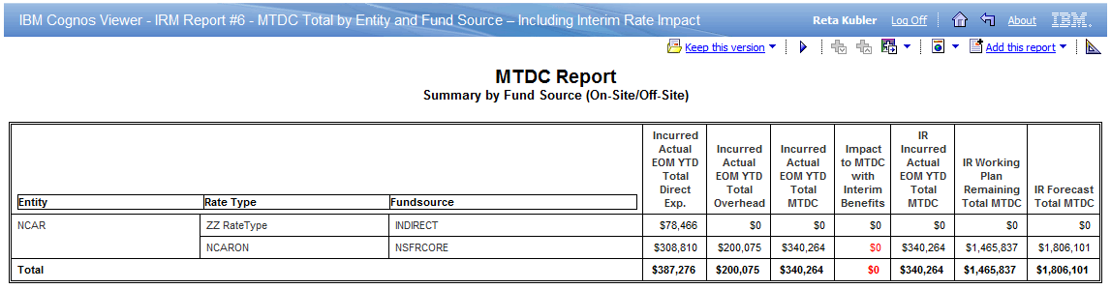

**IRM Report #7 - MTDC Total by Entity and Normalized Fund Source – Including Interim Rate**

**Impact**

**This report provides information at the entity level, by rate type and normalized fund source, on the impact of an interim Benefit Rate change on MTDC as well as a forecast of how such a change might impact the overall MTDC estimate for the year.** The IR Forecast for MTDC includes interim benefit rates applied to actuals plus interim benefit rates applied to Working Plan Remaining. In the example below, there has been no change in the interim benefit rate and therefore, no impact. *(The example, with Division“19” was continued; this report would typcally be run with the entity prompt rather than the account prompt.)*

User prompts for running this report require fiscal year and one other selection. Typically users select information entity, but can also select or narrow down by account, division code, contract, fund source, and rate type.

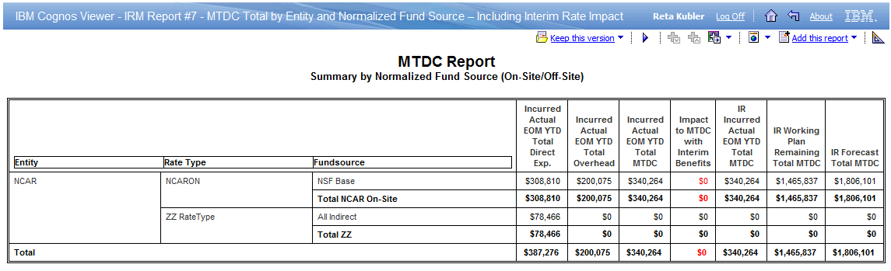

**IRM Report #8 - Forecast Expense Report Summary by Expense Class Interim Planning Rates**

**This report provides a forecast of how changes in all interim rates might impact at an expense class level.** This includes the overall Forecast Funds Available at the Interim Rate (IFAS Budget vs.IR Forecast) and the difference between the Forecast based on the Provisional Rates and the Forecast based in the Interim Rates,to show the impact of the rate change. The report provides a summary at the expense class level of the overall selection and account key detail at the expense class level for all they keys within that selection. In the example below, there has been no change in the interim rates and therefore, no impact.

**NOTE** - This report is also used by Project Accounting when you begin to close out an award (WRAP status) to show that it is not or will not be overspent based on interim rates, insuring it’s not overspent and there is no forecast expenses.

User prompts for running this report require fiscal year and one other selection. Typically users select information entity, but can also select or narrow down by account, division code, contract, fund source, and rate type. (While account selection can be narrowed by Acct Status, be aware that selecting only active keys elminates information for keys that had been active earlier in the year but are no longer active.)

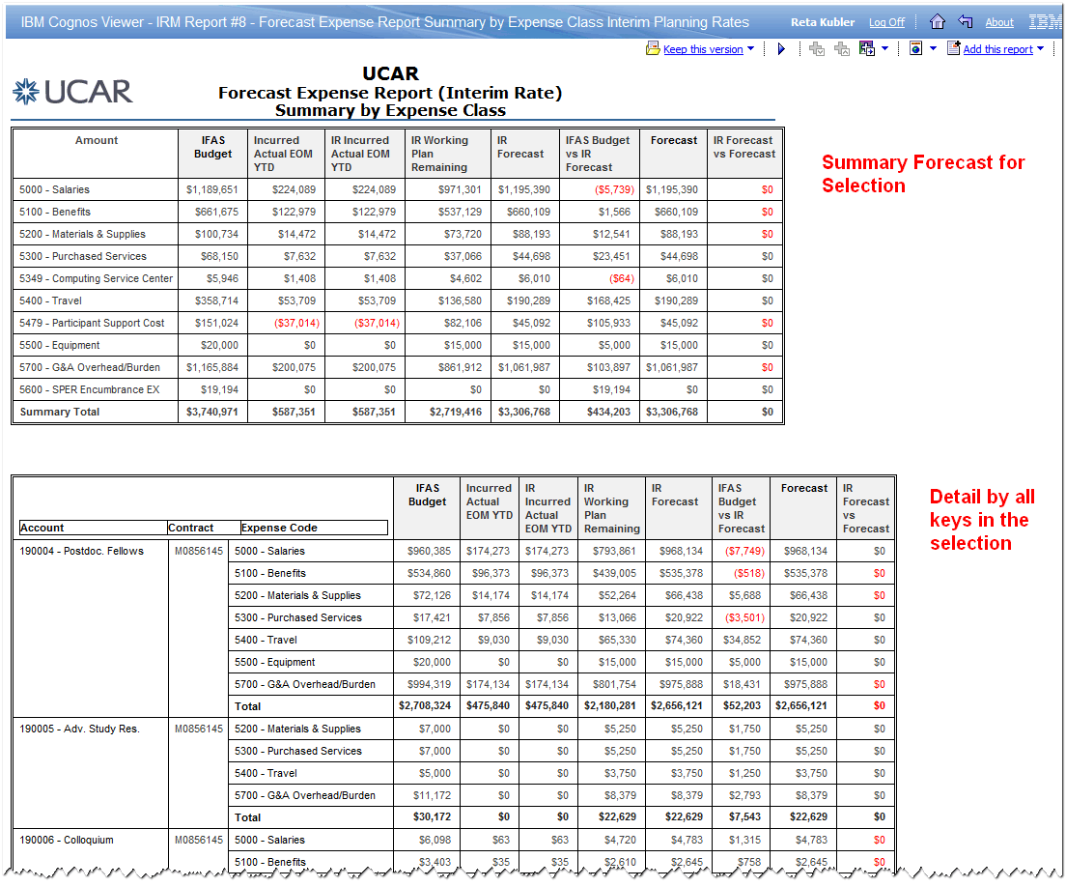

**IRM Report #9 - Forecast Expense Report Summary by Account Interim Planning Rates**

**This report provides a forecast of how changes in all interim rates might impact at the account key level.** This includes the overall Forecast Funds Available at the Interim Rate (IFAS Budget vs. IR Forecast) and the difference between the Forecast based on the Provisional Rates and the Forecast based in the Interim Rates to show the impact of the rate change. In the example below, there has been no change in the interim rates and therefore, no impact.

User prompts for running this report require fiscal year and one other selection. Typically users select information entity, but can also select or narrow down by account, division code, contract, fund source, and rate type. (While account selection can be narrowed by Acct Status, be aware that selecting only active keys elminates information for keys that had been active earlier in the year but are no longer active.)

