CPM Quick Reference – Basics for Staffing and Salary Planning in FAB / UI – % in Key AND Hourly (FY2015)

Helpful Hints:
- Saving - Click off cells to save – see the , save often
- To refresh grid, click on grid to activate it and then click refresh
- Check your Dimension Selectors –
  - Verify that all grids that reference Fiscal Year are on the Fiscal Year you are working on.
  - Verify that all grids you are entering using the Working Plan Scenario.
- Copy/Paste in Grids - to copy to other rows, use Ctrl+C and Ctrl+V and allow the web application to access your clipboard.
- Casual employees - best to use Work Time % rather than FTE info on Casuals below.
- % in Key Planning - For ease of use with copying to the What-if Scenario, it is best to edit old assignments rather than deleting them, which can mean changing end dates as necessary and leaving old assignments in the planning grid.
- Remember to set the Year to 2015 and save the new filters for grids that use Fiscal Year.

Items you may need for reference when planning employee salaries
- List of all account keys with Proposal #, Acct Manager, Contract ID, Fund Source, Acct Description
- Internal list of all pending proposals with Status, Fund Source, PI, Planned Start Date
- List of all accounts with current funds available and forecast funds available
- List of all contracts and end dates (ART Report under Contracts - Direct Awards With Associated Account Keys By Div.rpt)
- Any other materials you use in planning where folks may be allocated over the next fiscal year

Summary of Steps
Step 1 - Unassigned Employee Report Grid
Scan to Verify Unassigned Employees from Your Group - make note of people who are not assigned to any account key and need to be added to the Planning Grid below. (See note in Casual Section.)

Step 2 - Examine and Edit Plan Employee Salaries Grid
Scan to see if there are Term Dates you plan to extend Next Fiscal Year or planned Promotions or Reclassifications, or FTE changes. Use “Add Row Copy” to create Next Records to reflect these planned changes and allow the changes in $ to flow through your fiscal year plan.

Step 3 - Examine and Edit Employee Assumptions Grid – Change CSC and Work Time
Scan to see if any CSC assignments need to be updated in your plan and make any planned Work Time adjustments that may vary from the default 85%. (For Hourly Planning, updating Work Time Assumptions impacts calculations in the Workable Hours Grid.)

Step 4 - Create a Generic Placeholder Account Key
If you have not already created one, this generic TBD placeholder key can be used for planning assignments where the funding or project is really unknown at this point and there is not a proposal placeholder key. (This allows you to fully plan employees while identifying high potential risk.)

Step 5 - % in Key - View Employee Account Allocation Data Entry Grid AND Employee Projection Annual Report Grid via Tile Horizontal
With all other grids closed, these two allow you to create and edit assignments and verify a person is fully planned. Start Planning with Dimension Filters that allow you to see ANY employee on YOUR keys with 2015 for the year. Save the new Dimension Filters.

Step 6 - % in Key - Enter / Edit Account Key Assignments in the Employee Account Allocation Grid – Filtering by Employee
Edit existing assignments and create new assignments as necessary. It’s much easier to do this Selecting one specific Employee at a time in both the Allocation and Projection Grids via “Filter Row” and then begin making changes.

Step 6.1 - % in Key - Verify in the Employee Projection Annual Report Grid – Filtering by Employee
Refresh the Projection Grid and check Person Year to verify the employee is fully planned.

Step 6.2 - % in Key - Verify in the Employee Projection Annual Report Grid – All Employees
After planning/verifying individual employees, view ALL employees, grouping by employee, in this grid to easily scan to identify possible issues where someone is not fully planned. This Report grid is a summary of all the information you entered or altered in ALL the Plan Employee Salary Grids and great for verifying entry.

Step 5 - Hourly - View Employee Account Allocation Data Entry Grid for Hours for Quarters OR Months and Open the Workable Hours Report Grid via Tile Horizontal.
With all other Grids closed, these two allow you to create and edit assignments and verify if a person is fully planned according to calculated Workable Hours. Start Planning with Dimension Filters that allow you to see ANY employee on YOUR keys with 2015 for the year. Save the new Dimension Filters.

Step 6 - Hourly - Enter / Edit Hourly Account Key Assignments in the Employee Account Allocation Grid – Filtering by Employee
Edit existing assignments and create new assignments as necessary. It’s much easier to do this Selecting one specific Employee at a in both the Allocation and Workable Hours Grids via “Filter Row” and then begin making changes.

Step 6.1 - Hourly - Verify in the Employee’s TOTALS in the Employee Account Allocation Data Entry Grid
Use Workable Hours as a starting point and compare with TOTAL Hours planned in Allocation Grid for the employee to see if the employee is fully planned. (Workable Hours may vary by employee based on FTE, Work Time Assumption as well as when pay periods fall.)

Step 6.2 - Hourly - Verify in the Employee Projection Annual Report Grid – All Employees
After planning/verifying individual employees, use this Report Grid to view ALL employees, grouping by employee, to scan and easily identify possible issues where someone is may not be fully planned. This Report grid is a summary of all the information you entered or altered in ALL the Plan Employee Salary Grids and great for verifying entry.

General Steps for Staff and Salary Planning

1 - Scan Unallocated Employees by Year Report Grid
- Filter by HR Org
  - Are there staff listed from your Division or program who have no time planned against any account key?
- Verify "Unassigned Employees" for your group
  - Should the unassigned employee have planned time? Some casual or emeritus employees may be OK – see FYI Casual information below. A new employee may need Acct Key assignments added.
  - Are employees who need assigned keys listed on your Employee Salary Planning and Employee Assumption Grids? If so, they only need to be added to the Employee Account Allocation Grid.

2 - Examine Plan Employee Salaries Data Entry Grid
- Check all Actual Position/Term End Dates prior to the End of the Planning Year
  - For any Term Employees, change PLANNING Position End Dates for those positions that are PLANNED to extend beyond their current HRIS term end date. (The HRIS Term date in the grid is the official term date and can only be modified through HR.)
- Use Add Row Copy for new lines for any PLANNED promotions or reclassifications
  - Change in the new line - Position Start Date, Salary, Position Code (Job Title)
  - Change the end date of the old position, to be one day prior to start of the new position
- Use Add Row Copy for new lines for any PLANNED FTE Changes
  - Change in the new line - FTE, Position Start Date, Position End Date
  - Change the end date of the original FTE to be one day prior to start of the new FTE
  - Add another line and edit as above if FTE changes again
- Add Placeholder Employees for PLANNED employees that are not yet in iVantage, i.e. new hires, planned hires…
  - Create a Placeholder Employee Under "Tools" > "Employee Placeholders" > "Add"
  - HINT - Begin the Name/ Description with "PH" and your Div/Prog to easily identify this as a placeholder. For example - PH-ACD SW Eng
  - HINT - Enter annual salary - hourly will populate on saving
  - NOTE - This placeholder is automatically added to your Plan Employee Salaries Grid
  - NOTE - This placeholder will need to manually be added to your Employee Assumptions Grid for CSC charges and / or Work time Adjustment
  - NOTE - This placeholder will need to manually be added to your Employee Account Allocation Grid
  - NOTE - Placeholders should be used sparingly; they cannot be deleted but can be "recycled". See more on planning placeholders at the end of the document.

3 - Examine Employee Assumptions Data Entry Grid
- Check CSC Listing
- Add all new placeholder employees to the CSC grid via Add Row Copy; placeholders do not automatically add to this grid and CSC costs will not automatically be in your total planned costs.
    - HINT - Use the drop down filter to view CSC assignments of your staff outside your division.
    - NOTE - Typically changes apply only to added placeholders or to future CSC Division changes for staff on your account keys. Future CSC changes should be done on new line number.
    - Warning – This grid does not impact IFAS CSC assignments for actual application of rates.

- Work time Adjustments
    - NOTE - The system defaults to the average 85% work time unless there is an adjustment on this grid. Typically you only need to change Work Time in a handful of cases, although some groups may plan everyone at 86% to provide some flexibility in the plan.
    - Identify employees who vary enough from the 85% work time that there is value added in changing Work Time for planning purposes
    - If you do need to change someone, change the work time and the applicable dates of that change.
    - Warning - If you have a start date and end date with no %, meaning it says "0.0", the system is calculating 0.0% for those dates, which may cause the person to be unplanned for that period and to show up incorrectly or not at all in the Employee Projection Report.
    - Warning - Do you have an end date but no start date? This may also cause issues in the Employee’s plan for the year.

4 - Create a Generic Placeholder Account Key
- Create a generic TBD placeholder account key for your group to use for planning assignments where the funding or project is really unknown at this point so there would be not a proposal placeholder key. This allows you to fully plan employees, which makes verification easier and also helps identify potential high risk, where an actual funding source may not yet be identified.
  - HINT - Begin the Name/ Description with "PH" and your Div/Prog to easily identify this as a placeholder and for easy identification, you might include “TBD” or something similar. For example - "PH-MMM Key TBD"

5 - % in Key - View Employee Account Allocation Data Entry and Employee Projection Annual Report Grids
- Select "Tile Horizontal" from under the “Window” Tab with all other grids closed.
  - HINT - On the Projection Report Grid, which is grouped by employee by default, right click the Employee column header and click "Ungroup" to remove the filter and have access to the Filter Row.

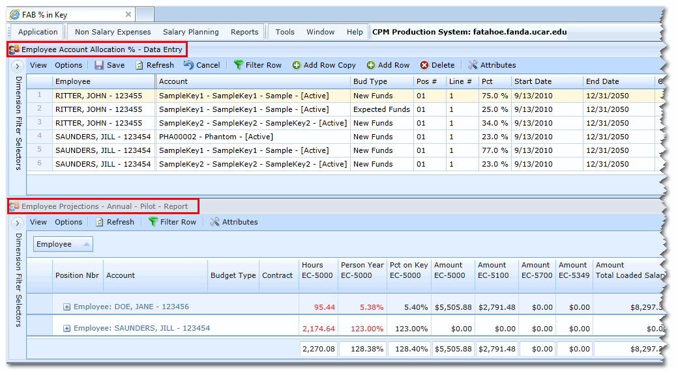

6 - % in Key - Enter / Edit in the Employee Account Allocation Data Entry Grid
  - HINT - to plan for a specific employee or account key, it is easiest to use Filter Row on both grids to limit the view to the relevant data, i.e., the employee’s last name.
  - HINT - The UI grids Differ from Excel - Use "Add Row Copy" to change entries for Employee Name, Account, Budget Type and Line # and if no longer necessary, delete the old row. (Changing these items in the cell actually creates a new record and new row when you save the change.) Percent, Start Date and End Date can be edited directly on the grid and no new record is created
  - NOTE - Budget Type for salaries defaults to "New Funds", so this needs to be changed if another budget type is needed. Typically "Expected Funds" is used for TBD and placeholder keys.

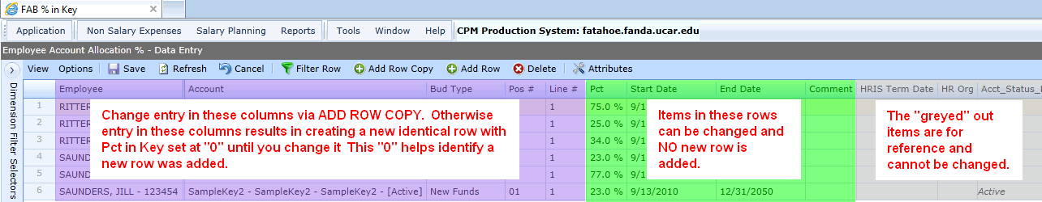

- Select an Employee via Filter Row on each grid and make necessary changes to planned account key assignments. (It’s much easier to make and verify changes looking at just one person at a time in each Grid.)
  - To change a record or add a new record – select a row and press ADD ROW COPY to obtain a new row to edit.
  - Within the new Row you can make the necessary changes as follows:
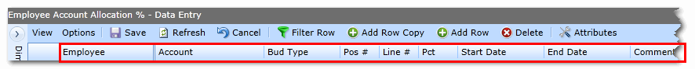
  - Change Employee Name Field – use Filter Row to filter by the name of the person you are working on, to add a new employee to the grid, use add row copy, begin typing the new last name and select from the drop down box that appears.
  - NOTE – If you add a new employee via “Add Row Copy”, you will need to re-filter on that name to see them.
  - Change Account Key Field - begin typing the account key and select from the drop down box that appears
  - Change Budget Type Field – defaults to "New Funds", this needs to be changed if another budget type is needed. The drop down arrow provides a list of types from which to select. Typically the budget type would be “New Funds” and typically "Expected Funds" is used for TBD and placeholder keys. This entry is most critical for budget uploads.
  - Position # Field - typically this is “1” except for a few employees who have two or more distinctly different appointments, job titles and associated salaries.
  - Line # Field - The system requires a line # for each new entry. Use #1 for the first entry for a person on an account key, use #2 for second entry on the same key for the same person and so on…. WARNING - If you accidently put #1 for both entries, the system defaults to the assignment with most recent dates and you will lose the other entry.)
  - Start Date Field – enter the date the person is planned to begin working on the project.
  - End Date Field – enter the date the person is planned to stop working in the project.
  - HINT - Do not use the “12/31/2050” default of iVantage; using the award end date helps you identify potential gaps in funding / coverage much more easily.
  - NOTE – The Contract POP Start and End dates associated with the Account Key are in the Employee Account Allocation Grid for reference.
  - Comment Field – this allows the user to add notes for themselves and others who work with their group in the UI.
  - NOTE - You can add any UCAR employee to your keys and salary plan, but you cannot put employees on keys outside your Lab / Program. Assignments on others keys need to be coordinated with the administrator within that Lab/Program.
  - NOTE - For unfunded or unknown portions of an employee’s time, use the TBD placeholder account key with Budget Type "Expected Funds"

6.1 - % in Key - View the Employee Projection Annual Report Grid to verify the Employee is Fully Planned:
- In the Employee Projection Annual Report Grid:
  - Verify that Group by Employee is OFF
  - Verify that you have selected the employee via filter row that you changed or added to the Employee Allocation Grid
  - Check Percent in Key and Person Year for the employee
  - HINT – Generally you expect the Total Percent in Key to be 100% and the Total Person year to match the actual FTE. (Percent in Key at 100%, means the person is 100% planned to a key or keys regardless of FTE or portion of the year an employee is here. The Person Year % reflects dates planned to keys and should match the employee’s FTE unless the employee is here less than the full year.)
6.2 - % in Key – AFTER PLANNING ALL EMPLOYEES, review the Employee Projections Report Grid.
  - Take all filters off to see all employees in the Report Grid.
  - Group the Report by Employee, moving the Employee Attribute to the Group Panel; verify total person year and percent in key totals. Anything less than 100% will show up in red.
  - Check possible issues, errors in Person Year and Percent in Key columns.
  - HINT – Again, generally you expect the Total Percent in Key to be 100% on key and the Total Person year to match the actual FTE. If this is not the case, it’s an employee to check how keys are planned.
  - HINT – to see all employees with Totals AND Detail, when grouped by employee, Right Click the “Employee” header at in the Group By Panel at the top of the grid and select “Full Expand”

5 - Hourly - Employee Account Allocation Quarterly or Monthly Grid
  - Set and save Dimension Filters for the current Fiscal year.
  - Start with Dimension Filters that allow you to see ANY employee on YOUR keys with the year set at 2015.
  - You can later verify that your employees are planned across UCAR with Dimension Filters that allow you to see YOUR employees on ANY keys in UCAR with the year set at 2015.

Sample of Quarterly Grid
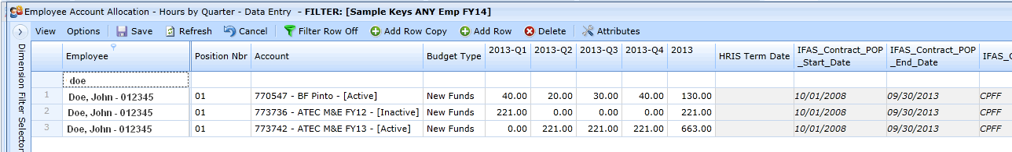

6 - Hourly - Enter / Edit in the Employee Account Allocation Data Entry Grid
  - HINT - to plan for a specific employee or account key, it is easiest to use Filter Row on both grids to limit the view to the relevant data, i.e., the employee’s last name. This allows you to see the Quarterly Totals and Overall Totals for the employee.
  - To add a new row or new account for an individual, use “Add Row Copy”
  - The Hourly Allocation Grids allow editing of the data entry cells; you can change a cell and save and it will not create another record; the change is saved.
  - NOTE - Budget Type for salaries defaults to "New Funds", so this needs to be changed if another budget type is needed. Typically "Expected Funds" is used for TBD and placeholder keys.

- Select an Employee via Filter Row and make necessary changes to planned account key assignments. (It’s much easier to make and verify changes looking at just one person at a time in each Grid.)
  - To add a new record – select a row and press ADD ROW COPY top obtain a new row to edit.
  - To change a record – simply type over the entries you wish to change and save.
  - Within the new Row you can make the necessary changes as follows:

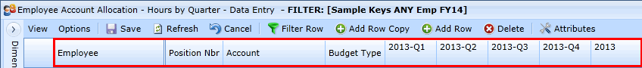
  - Change Employee Name Field – use Filter Row to filter by the name of the person you are working on, to add a new employee to the grid, use add row copy, begin typing the new last name and select from the drop down box that appears.
  - NOTE – If you add a new employee via “Add Row Copy”, you will need to re-filter on that name to see them.
  - Position # Field - typically this is “1” except for a few employees who have two or more distinctly different appointments, job titles and associated salaries.
  - Change Account Key Field - begin typing the account key and select from the drop down box that appears
  - Change Budget Type Field – defaults to "New Funds", this needs to be changed if another budget type is needed. The drop down arrow provides a list of types from which to select. Typically the budget type would be “New Funds” and typically "Expected Funds" is used for TBD and placeholder keys. This entry is most critical for budget uploads.
  - Change / Add Hours for each Quarter or Month – type planned hours in each quarter.
  - NOTE – The Workable Hours Report Grid calculates the Hours that are available within each Quarter. It’s much more accurate than multiplying the available hours by work time and FTE, it also take into account actual available hours based on workable days and when pay days and accruals fall. This can be quite useful in planning hours by Quarter or Month.
  - NOTE - You can add any UCAR employee to your keys and salary plan, but you cannot put employees on keys outside your Lab / Program. Assignments on others keys need to be coordinated with the administrator within that Lab/Program.
  - NOTE - For unfunded or unknown portions of an employee’s time, use the TBD placeholder account key with Budget Type "Expected Funds"

6.1 - Hourly - Verify the Employee is Fully Planned:
- In the Employee Account Allocation Hourly Data Entry Grids:
  - Compare Hours by Quarter or Month with your plan or the Workable Hours Report Grid
  - Compare the Total Overall hours with your plan and/or the Workable Hours Report Grid
  - HINT – To easily compare, have only these two grids open and select "Tile Horizontal" from under the "Window" Tab with all other grids closed, use Filter Row to see one person at a time and their totals.
  - NOTE – The Workable Hours Grid calculation is based on an FTE, Start Date and End Date AND the Work time Assumption as well as the actual working days in that specific period.

6.2 - Hourly – AFTER PLANNING ALL EMPLOYEES Review the Employee Projections Report Grid.
  - Take all filters off to see all employees in the Report Grid.
  - Group the Report by Employee, moving the Employee Attribute column header to the Group Panel; verify total person year and percent in key totals. Anything less than 100% will show up in red.
  - Check possible issues, errors in Person Year and Percent in Key columns.
  - HINT –Generally you expect the Total Percent in Key to be 100% and the Total Person year to match the actual FTE. (Percent in Key at 100%, means the person is 100% planned to a key or keys regardless of FTE or portion of the year an employee is here. The Person Year % reflects dates planned to keys and should match the employee’s FTE unless the employee is here less than the full year.)
  - HINT – to see all employees with Totals AND Detail, when grouped by employee, Right Click the “Employee” header at in the Group By Panel at the top of the grid and select “Full Expand”

FYI - Planning for Casual Employees
Both % in Key and Hourly (For % in Key, it calculates the correct cost and hours, for Hourly, this calculates the hours in the Workable Hours Grid.)
- Casual Staff who are planned to work 999 hours or less in FY2015.
  - NOTE: By default, Casual FTE's are 1.0 in the Plan Employee Salaries Grid and all Work Time defaults to 85%. You can better estimate their costs by:
- Plan Employee Salary Grid
  - Casual Employee’s FTE is 100%
- Employee Allocation Grid
  - Assign the employee to the appropriate account key(s)
  - You may need to use “Add Row Copy” if the employee has no planned keys
- Employee Assumptions Grid
  - Set the Casual Employee’s PLANNED Work Time to appropriate level – SEE BELOW
  - Set the Start Date for Work Time change to 10/1/2014 or as applicable
  - Set the End Date for Work Time change 9/30/2015 or as applicable

NOTE - Dates for Work Time adjustment are necessary

Approximate Hours Planned | Work Time |  | Enter Begin and End Dates or as Applicable
1000 | 48% |  | from 10/1/2014 thru 9/30/2015
750 | 36% |  | from 10/1/2014 thru 9/30/2015
500 | 24% |  | from 10/1/2014 thru 9/30/2015
250 | 12% |  | from 10/1/2014 thru 9/30/2015
100 | 5% |  | from 10/1/2014 thru 9/30/2015
50 | 2% |  | from 10/1/2014 thru 9/30/2015

Casual Staff or Staff on Leave who are NOT PLANNED to work at all in FY2015, but who should remain active:*
- Employee Assumptions Grid
  - Set the employee’s PLANNED Work Time to "0%"
  - Set the Start Date for Work Time change to 10/1/2014 or as applicable
  - Set the End Date for Work Time change 9/30/2015 or as applicable
  - NOTE - Dates for Work Time adjustment are necessary

* If you have casual staff listed as “Unassigned” in the Unassigned Employee Report who are no longer active and will not work again, contact HR about removing them via Official Termination, otherwise they keep showing up as someone you need to check or fix.

FYI - Placeholder Tips and Tricks
- Any fields you create in Placeholder can be edited.
  - HINT - Begin all Placeholder Names, both Employees and Accounts with PH-DIV for easy identification.
  - HINT - For any placeholder associated with a proposal, put the proposal number in the name. This help with recycling it - it's easier to determine that this person or award it now active.
  - HINT - Placeholder keys may take a few minutes to become available to add to grids.

FYI - Dimension Filters for Initial Planning in the Employee Allocations Grids and the Employee Projections Report Grid
Your Account Keys with Any Employee in UCAR
- Set Account to Your Accounts via the Hierarchy
- Set Employee at Level 0 via subset to see all folks you are planning to your keys
- Set Year, Date or PP to 2015
- Save Dimension Filter
- Set Filter as DEFAULT if you will be working on this for a while.

FYI - Dimension Filters for Verifying Members of Your Group is Fully Planned across ALL UCAR keys
Your Employees on Any Account Key in UCAR
- Set Employee to Your Group via the Hierarchy
- Set Account to Level 0 via Subset to see ALL keys your group is planned on
- Set Year, Date or PP to 2015
- Save Dimension Filter
- Set Filter as DEFAULT if you will be working on this for a while.

FYI - Work Time / Available Hours to Work Calculation
- TM1 uses a formula like Excel's Networkdays function; it recognizes where weekends fall and counts actual available week days / work days, which is more is more accurate than what we've been doing.

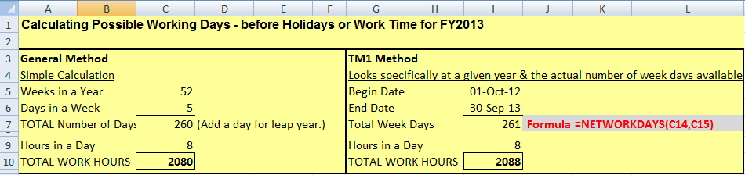

- There is a spreadsheet available that uses this to help verify individual employee’s costs in the UI. If this is something users would find helpful, we can put it on the Drupal page for easy access.

