CPM Quick Reference – Basics for Non-Salary Planning (FY2015)

Reminders:
- Click off or tab off ells to save – see the to verify edited cells, Save Often
- To refresh grid, click on grid to activate it, then click refresh
- Check your Dimension Selectors –
  - Verify that all grids that reference Fiscal Year are on the Fiscal Year you are working on.
  - Verify that all grids you are entering using the Working Plan Scenario.
- Copy/Paste in Grids - to copy to other rows, use Ctrl+C and Ctrl+V and allow the web application to access your clipboard
- All the Non-Salary Planning Grids are Fiscal Year based, remember to set the Year to 2015 and save the new filters for grids with new names.

Summary of Steps for Non-Salary Planning
Step 1 – Optional Priming or Prepopulating Non-Salary Plans
For the Next Fiscal Year, users may choose to utilize data from the current fiscal year to prepopulate the plan or specific keys in the plan via Scenario Copy features and then update and edit that information.

Step 2 - Enter/Edit in the Plan NonSal Expenses – Annual Spreading Working Plan Grid
Data Entry in this grid is at the bigger picture level, estimating expenses in each Expense Class for FY14. This information is then spread uniformly across months in the Monthly Planning Grid. This Grid is where general Non-Salary Planning begins for the upcoming Fiscal Year.

Step 3 - Examine and Refine Planning in the Monthly Planning Grid
Editing in this grid allows the user, where relevant, to refine planning of Non-Salary Expenses at the monthly level.

Step 4 - Plan Subaward MTDC Exclusions
Data Entry in this grid allows the user to plan for specific subaward exclusions from MTDC for the fiscal year.
Step 5 – Verify Data Entry Once Planning is Complete
Scan Active Keys in the No Planned Expenses Report Grid to determine if there are keys listed from your group that should have planned expenses. Review Total Planned Expenses in the Non-Salary Annual Spreading Grid filtering by Account Key, Contract, Fund Source and compare with budgets, expected budgets, general knowledge of the key project…

Planning Non-Salary Expenses
- HINT - Before planning Non-Salary expenses, complete FY15 Salary Plans. Your planned salary expenses with applied benefits, OH and CSC by account key populate the “reference” columns in the Plan Non-Salary Annual Spreading Grid for FY2015.
- NOTE - All non-salary expense are planned at the level of Account Key, Expense Class and Budget Type. For example:
  - 123456 5200 MS New Funds $20,000
  - 123456 5200 MS Committee Carryover $ 1,000
  - 123456 5200 MS Fund Transfer $ 5,000
- Budget type is most critical in planning of Funds that are uploaded from the system, at this time uploads include only NCAR Indirects, CSC and NSF Target funds, but larger Cooperative Agreements may be added. In some cases you may choose to plan only to “New Funds”. Typically "Expected Funds" would be used for TBD and placeholder keys.

1 - Optional Priming or Prepopulating Non-Salary Plans
- NOTE- Prior to entry of Non-Salary Expenses for FY2015, ONLY Account Keys with Planned Salary for the selected Fiscal Year will show up in your Non-Salary Annual Spreading Grid. This is because the “Reference” columns in that grid (the light grey columns that cannot be edited) are populated with a summary of your planned salary expenses plus applicable benefits, OH and CSC by account key.

- There are benefits to priming and benefits to a blank slate.
  - Priming
    - + Provides a starting point for data entry of Non-Salary Plans
    - + Provides the user clues or hints for planning the next fiscal year
    - + Provides more keys on the grid, less need to recall missing keys
    - - Some keys copied in may be closed and need to be deleted
    - - Priming Data is based budgets or plans from previous years that may not even closely reflect plans for FY2015 and requires a tremendous amount of edit and proofing, particularly editing budget type
  - Data Entry with NO Priming
    - + Provides a clean slate for data entry of Non-Salary Plans
    - + The user can easily see what’s been entered and what remains, without the possibility of missing something and leaving old, incorrect numbers in the grid
    - - Need to identify and add keys not listed but that should have planned Non-Salary Expenses in FY2015 (Recall, all keys with planned salary expenses for FY2015 will be listed already.)
    - - May need to look at reports from the current year as a prompt to help identify keys that don’t have salary expenses and are not in the grid yet for FY2015.
  - Data Entry and Partial Priming
    - In the Scenario Copy Process, you can copy select keys; you do not have to copy the entire plan. It may be helpful to copy only certain keys.

Non-Salary Copy Processes
N1 - Non Salary Planning - Copy Non Salary
- Copies Non Salary Planning Data in both the Spreading and Monthly Grids from one scenario or year to another.
- Cannot be used to copy from IFAS Budget or Incurred Actuals - see N2.
N2 - Non Salary Planning - Copy Non Salary Budget or Actuals from IFAS
- Copies Non Salary Data from IFAS Budget or Incurred Actuals to the Spreading Grid in a planning scenario, which spreads evenly to the Monthly Grid.
- Copies Non Salary only, does not include account assignment data.

Summary of Scenario Management Copy Process Steps
- From the Processes menu select Scenario Management – Copy and select the specific copy process.
- In the Dimension Filter, click on cd_Employee and/or cd_Account to select the individual accts and employees or groups you would like to copy data to and from.
- As applicable, select both the Source and Destination Scenarios, both Source and Destination Years and Budget Type.
- Verify Selections.
- Click Run Process to complete the copy.
- Verify the Job Status – Completed or Fail in the Job Status Tab.
- Verify results in data entry grids for the Destination Scenario.

2 - Enter/Edit in the Plan NonSal Expenses – Annual Spreading Working Plan Data Entry Grid

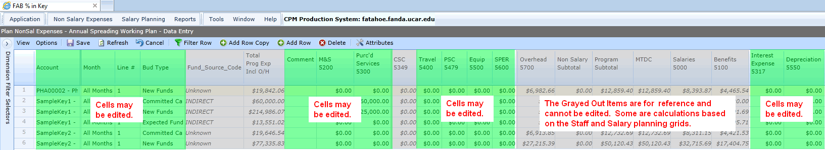
- Using Filter Row, select a single account or fund source or contract id to filter on and make changes as necessary for planned expenses. (It’s much easier to make and verify changes looking at just one key, contract or fund source at a time in each Grid.)
  - To edit an existing record, make the changes as necessary within that row.
  - HINT – The system sometimes creates a new record / row or saves the changes to an existing record / row or does not show the record at all depending on the following:
The system will create a new record when you:
    - Change Budget Type AND change or add any Non-Salary Expense or Comment
The system will NOT create a new record, but saves the changes in that row when you:
    - Change ONLY Budget Type on row with planned Non-Salary Expenses or a Comment
    - Change or add any Non-Salary entry
The system will not show the new record when you save and have:
- Changed only Budget Type AND there are no Non-salary expenses in the key. (The salaries in the existing key don’t copy and with “Zero Suppression”, you won’t see the key that has no expenses)
- Zeroed out all the Non-Salary entries and comment – “Zero Suppression”.
  - To add a new record – select a row and press “ADD ROW COPY” to obtain a new row to edit.
  - HINT – The system will not show the new record when you save if there were no entries for Non-Salary expenses or comments – “Zero Suppression”.
  - Within the new row or an existing row you can make the necessary changes as follows:
  - Change Account Key Field - begin typing the account key and then select from the drop down box that appears.
  - Do Not Change Month Field.
  - Change Line # Field – HINT - Most folks are not entering multiple line numbers in the plan, so are not using this. This level of detail in not required but available to users for planning purposes. The feature allows two entries on the same key for the same expense class and same Budget Type and requires Use of #1 for the first entry, use #2 for second entry. For instance two lines for travel on the same key and budget type, identifying the different reasons for the distinction in the comment field - $10K general travel, $10K training travel. WARNING - If you accidently put #1 for both entries, the system copies the new entry over your original entry.)
  - Change Budget Type Field – Only if another budget type, other than what is shown, or copied, is needed. The drop down arrow provides a list of types from which to select. NOTE - Typically the budget type can be “New Funds” and typically "Expected Funds" is used for TBD and placeholder keys. This entry is most critical for NCAR budget uploads – NEW funds = Target for Upload.
  - Change Comment Field – allows users to add notes regarding Non-Salary entry for a particular record / row.

- Enter/Edit the following TOTAL PLANNED Non Salary EXPENSES for the FISCAL YEAR in this KEY based on the selected BUDGET TYPE:
  - Change M&S Field
  - Change PS Field
  - Change Travel Field
  - Change PSC Field
  - Change Equipment Field
  - If applicable, Change SPER Field (Typically expense are NOT planned here.)
  - If Applicable, Change Interest Expense Field
  - If applicable, Change Depreciation Expense Field.
  - NOTE - Budget Type is critical for uploads, currently only NCAR Indirects, CSC and NSF Target. For planning expenses on fund sources and contracts that are not uploaded, "New Funds" and "Expected Funds" may be sufficient.
  - HINT - To add or change a fund type, use "Add Row Copy" and edit the new line.
  - HINT - If you zero out all the entries, the line "disappears" upon saving. Zeros are suppressed, so any lines with no planned expenses do not show up on the grid.
  - HINT - To remove a row or fund type without zeroing out the entries, select the row and click "Delete".
  - SAVE OFTEN!
- Check Total for the Account Key as You Enter
  - Verify totals for the account key, fund source or contract ID or other filter using the subtotals at the bottom of the grid as well as Totals and Subtotals provided in the columns.
  - HINT - You can re-order the columns in way that works best for you to enter and verify information and SAVE the view to keep the layout.
  - HINT – Recommend you move the “All Revenue and Expenses Amount” column over to the left so you can easily see planned fully loaded totals for the key at any time.
- Add Placeholder Account Keys for planned non-salary expenses on TBD projects.
  - NOTE - Typically these are "Expected" Funds.

3 - Examine the Monthly Planning Data Entry Grid
- Identify keys or projects that may require more specific Monthly Forecasting than the initial equal spreading across months and make changes for those items.
  - Filter by the specific account key and make changes in the months for expenses class for that Account Key as required.
  - HINT – Move the Total Column on the far right-hand side of the grid by September to see your overall total change as you edit months. (Save this change in the Grid Layout via “View, “Save Grid Layout”)
  - NOTE – You can Copy/Paste in Grids with Ctrl+C and Ctrl+V and allow the web application to access your clipboard.
  - HINT - Remember to keep one entry in the line before saving or with Zero Suppression, the line will not show up on your grid and you’ll have to add it via Add Row Copy.

NOTE – Relationship between the Spreading Grid and Monthly Grid
- The Spreading Grid data entry is for a single number in a Non-Salary Expense Class for the Full Fiscal Year.
- The Initial Entry in the Spreading Grid for an Expense Class is spread evenly across all months in the Monthly Grid for that Fiscal Year.
- The Monthly Grid can be edited as necessary to more precisely plan expenses for a Fiscal Year.
- The last entry in either Grid takes precedence and upon SAVE is the entry reflected in both Grids. For Example: I enter $12,000 in the Spreading Grid and SAVE; it spreads $1,000 to each month in the Monthly Grid. I then edit the Monthly Grid with $10,000 in June and all other months $0 and SAVE, the new overall number in the Monthly Grid AND Spreading Grid is now $10,000. If I then edit the Spreading Grid with $6,000 and SAVE, the overall number in both the Spreading Grid AND Monthly Grid is now $6,000 and it spreads $500 evenly to each month.

4 - Subaward MTDC Exclusions
- This grid populate with any M&S or PS entries from the Non-Salary Grid, assuming these are most likely categories for over $25K subaward OH exclusions.
  - NOTE - All equipment and PSC exclusions are in the Non-Salary grid.
- Identify any keys that have planned subawards greater than $25,000 during the fiscal year.
  - HINT - Sort "Amount" highest to lowest (with the arrow on the right hand side of the row label), where you have >$25K subawards where you have budgeted more than $25K in PS or M&S. You can also select the largest amounts from the drop down filter. You may want to use the Filter Row to see only the relevant key you are working on.
- Enter the # of subawards in "# or sub-contracts" for that account and expense class for the fiscal year.
- Enter the total amount in "Total $ Amt of Subcontracts & Pos> $25K" for all awards in that account and expense class for the fiscal year.
  - NOTE – because the foundation for non-salary planning is monthly, you must pick a month to plan your MTDC exclusion. This grid defaults to put MTDC exclusions in the month of September but you can use the Dimension Selector to change the month.

NOTE – To see Subawards that have exceeded the $25K threshold
- This IFAS report lists by Account Key all awards that have exceeded the $25K threshold within a given time period for a given Division Code. Not all items listed are exclusions, but it can be very useful in providing the user with a reminder of the OH Exclusions they may have had in previous years and which keys or awards they were under. It also provides a means of monitoring the status of Exclusions within a current fiscal year. It’s a very handy report.

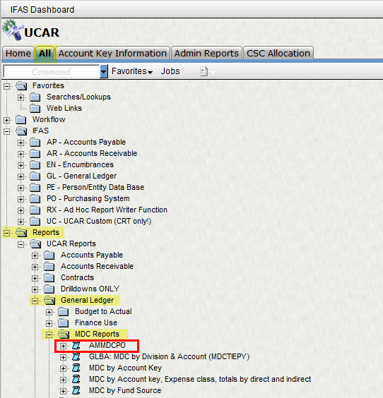

5 - Verify Data Entry
Scan Active Keys with No Planned Expenses Grid
- Filter by Your Group or Groups
  - See if you have active keys listed from your Division or Program that have not funds planned (You may want to create and save this dimension filter and set as default a filter for your Division or Program)
- Verify any "Unplanned Keys"
  - Are these keys that should have expenses planned in the fiscal year?
  - If so, determine if non-salary or staff expenses should be planned and add the information to your grids
Review Total Planned Expenses in the Non-Salary Spreading Grid
- Filter by such things as account key, contract or fund source to compare totals in your plan with budgets, targets, expected funds or other information to determine “reasonableness”.

FYI - Comparing Non-Salary Planning Methods

Option 1 - Monthly Spreading for Non-Salary Method
*BEST for Initial Planning and may be sufficient for some keys*
- Simpler Data Entry - One annual estimate and entry per key at expense class and budget type in the Spreading Grid which populates the Monthly Grid
- Entered in the Spreading Grid and Maintained in the Monthly Grid
- Spreads planned expenses evenly over all months
- Ideal for situations where spending is relatively consistent through the year
- If not maintained, forecast is typically "smoother" due to the average spreading of expenses across the year, forecast may be off if funds are spent at a higher or lower rate than the even spread; the greater the difference of actuals to plan the further the forecast may be off.
- Less likely to require detailed maintenance on every account key; some planned expenses may need to be maintained at the month level as actuals and plan differ.

Option 2 - Monthly Planning for Non-Salary Method
* BEST for tweaking Initial planned expenses by month in account keys where a very accurate forecast is necessary*
- More Complex Data Entry - Monthly estimate and entry per key at expense class and budget type in Monthly Grid
- Entered and Maintained in the Monthly Grid
- Allows the user to estimate where expenses will actually fall
- If not maintained / updated the forecast can be significantly off if larger expenses occur in months other than anticipated
- A lot of effort to maintain, look at actuals each month and re-estimate expenses for future months in the fiscal year at expense class and budget type

