**Planning Data and Grid Relationships**

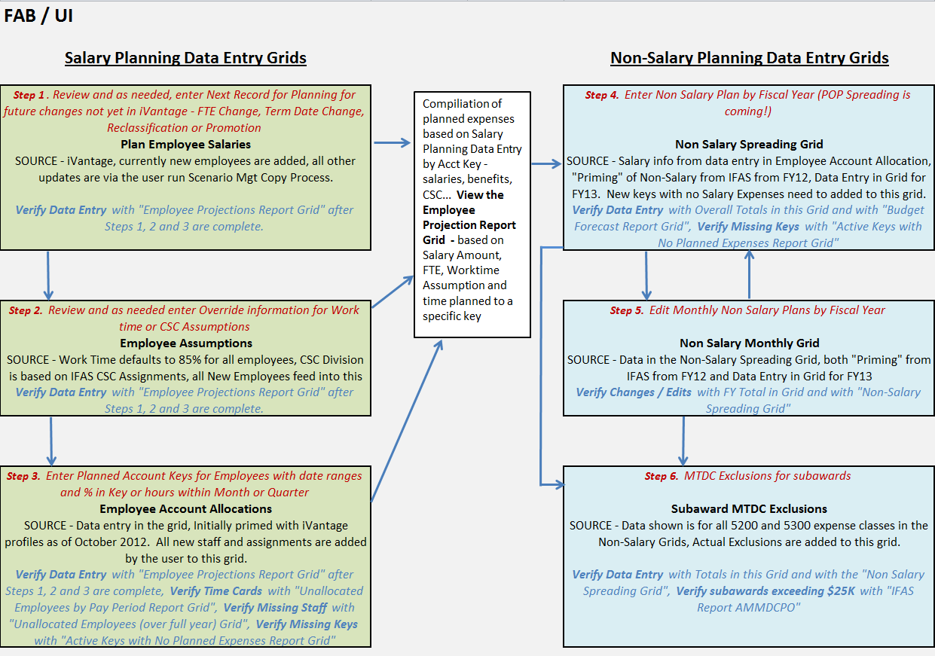

**UI Grid / Report Relationships**

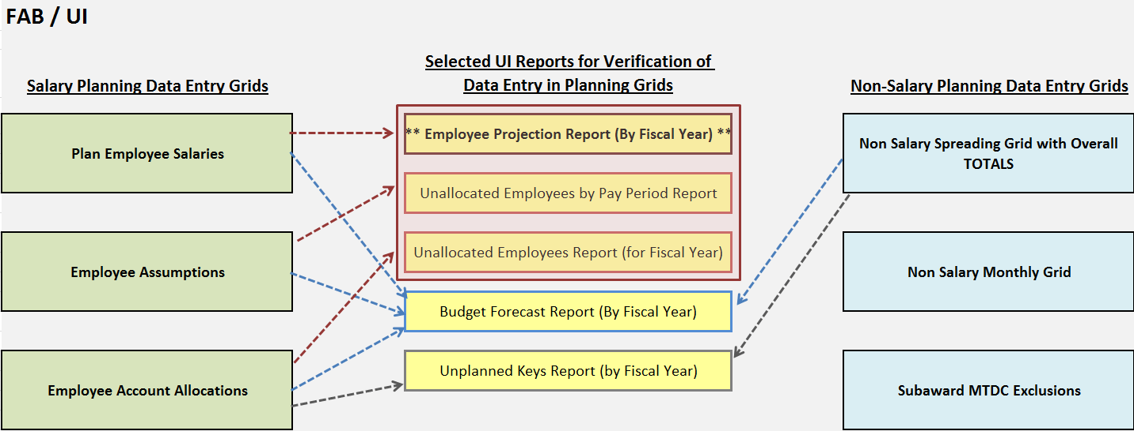

NOTE: Expected Budget Data Entry - provides user defined information by fiscal year the ABS Report re Expected Funds, User Defined POP and general notes.