# Cognos BI – Save Reports with Prompt Values

A Cognos report can be set up so that it runs with preselected prompts while “linked” to the original file to reflect updates to the original report. You run the report you wish to save prompt values in, create a Report View in your ‘My Folders’ and then set and save the desired Prompt Values in the Report View. Your report view will be connected to live data each time you run it.

1. **Run the Report**

* *Open the Report you wish to save with pre-selected values*
* *Make your prompt selections*
* *Run the report*

1. **Save the Report View**

After the report runs, click on ‘Keep this Version’ (upper center to right-hand corner of the screen) for the drop down menu and select ‘Save as Report View’

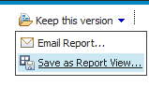

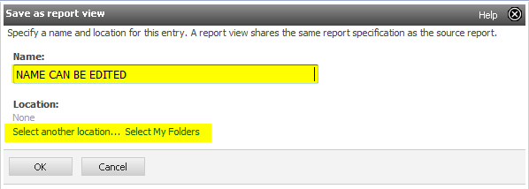

* **Report Name**: You can edit the name of the Report you are keeping to make it easier to identify.
* **Report Location**:
  + ‘Select My Folders’ to place the report in your main folder
  + ‘Select another Location’ to select a sub-folder or create a new sub-folder in My Folders
* Once the Name and Location are selected and correct, click ‘OK’
* Click the on the bent arrow in the upper left to return to the list of reports



1. **Set Prompt Values for Report View**

* Navigate to ‘My Folders’ Tab on the upper left-hand corner and to the location of your saved report.
* Click on “More”

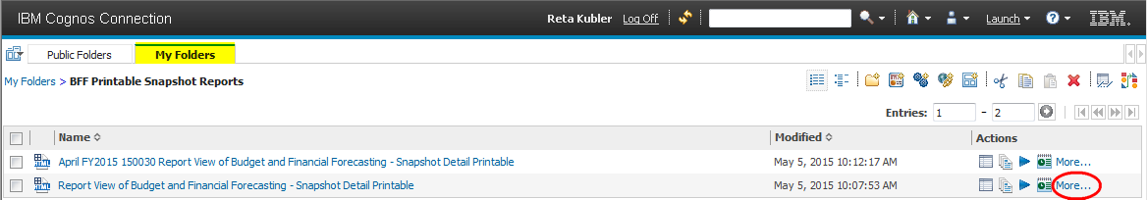

* Click on ‘Set Properties’

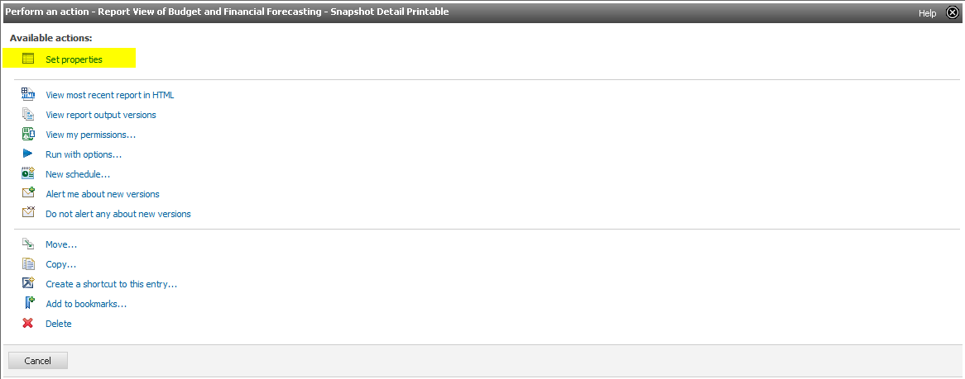

* Select the ‘Report View’ Tab

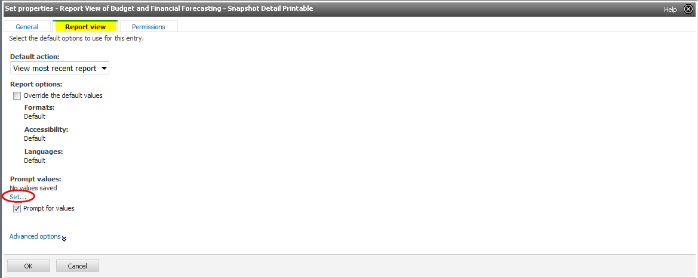

* Click on ‘Set’ under Prompt Values to return the report’s Prompt Page
* Re-enter your selection criteria and click ‘Finish’ to have the Prompts actually saved in your Report View.
* ‘Finish’ brings you back to the Report View settings. Click ‘OK’ to save the Prompt Values.

In My Folders navigate to where the Report View is save and click on the report name to run it.

To change Prompt Selections, Under Prompt Values, click ‘Edit’

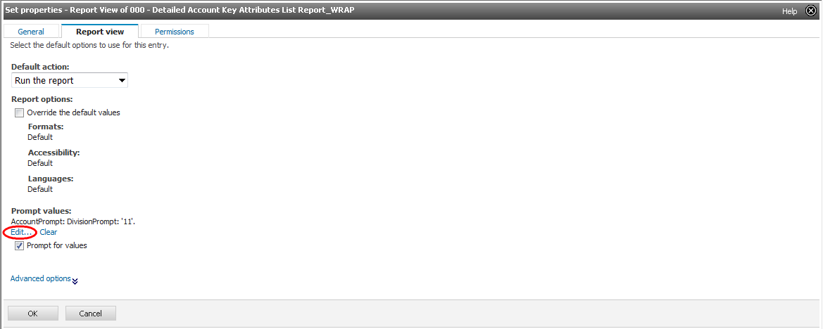

*NOTE* – if the changes are not in the report, but in the Prompt Page: Go back to My Folders and check in Set Properties and the Report View Tab to see that the selected Default Action is ‘Run the Report’ and not left on ‘View Most Recent Report’.