**Examples of Filtering for Mapping to Streamline Data Entry**

**Map Employee Salary to Projects or Activities Data Entry Grid:**

Note in this example the grid has 225 lines, (All employees and all instances of keys with planned Salary Expenses). Again, filtering, sorting and copying make data entry much simpler.

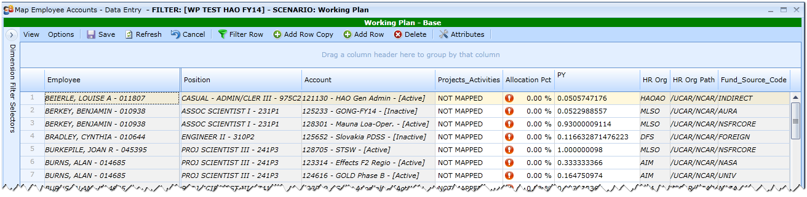

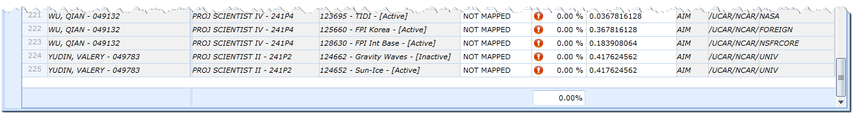

Upon opening the Grid all keys show up as “NOT MAPPED”. When you enter a Project / Activity in the NOT MAPPED line and save, the system creates a new record; there will be a line for the added item and the line for “NOT MAPPED” to allow additional data entry without Add Row Copy. The sorting examples below show how to simplify data entry while multiple lines are shown.

On this grid, mapping employee AND keys with Salary Expenses, the filtering can take place in several areas - HROrg, HROrg Path, Account Key, Position Title/ Employee or Fund Source.

**Assumptions for Sorting / Filtering to Map Salary Projects / Activities and Percentages**

* Employees within Sections / Groups are similarly mapped
  + HAOAO is mapped 20% Science, 20% Modeling, 20% Instrumentation, 20% Education, 20% Admin
  + Instrumentation Group is 100% Instrumentation
  + AIM Group is 50% Science, 50% Modeling
  + STWS Group is 75% Science, 25% Modeling
  + LSV Group is 100% Science
    - All staff with titles including Post Doc, Graduate Asst, Student Asst are mapped 100% to Education
    - Staff outside of HAO are mapped with the HAO group their HAO key(s) fall under.

Select all employees associated with AIM via the filter on the Column Header for HR Org – NOTE in the example there are 59 lines for Employees and Key assignments. (The HR Org Path can make it easier to identify your staff and HR Org’s from other Labs.)

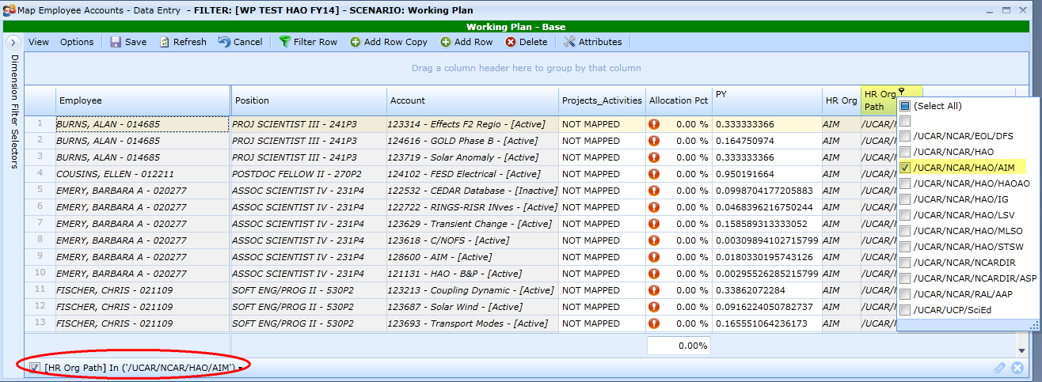

For the first row, select “TEST HAO Sci General” from the Project_ Activity List and enter 50% in Allocation %. Copy these entries down to ALL the other keys. You can copy both columns at the same time. This new entry is now copied through all 59 lines.

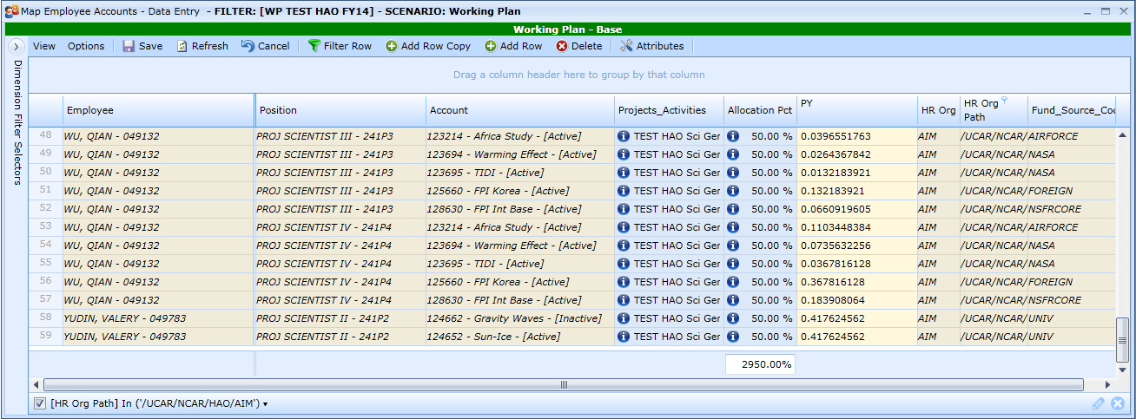

Save the entries. Notice the new entries and “NOT MAPPED” for entry of each key.

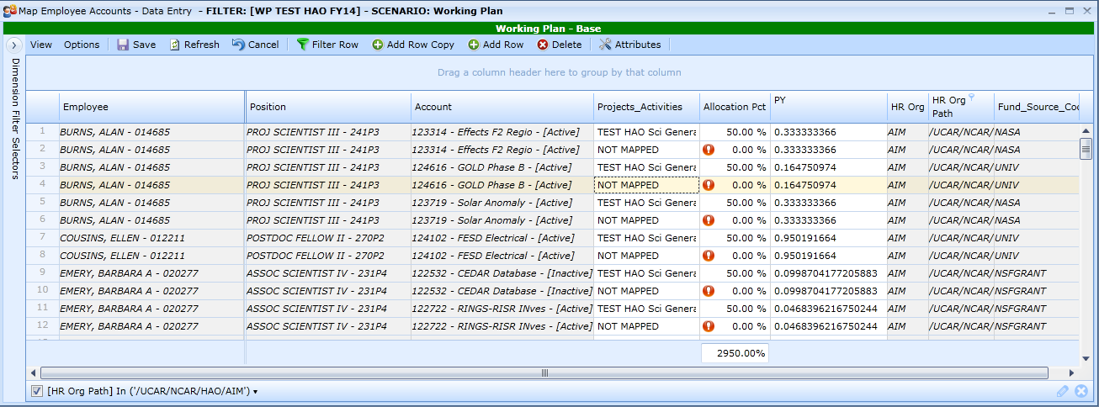

Click on the Projects Activities column header to sort items together. Now All “NOT MAPPED” are grouped and all the “TEST HAO Sci General” are grouped.

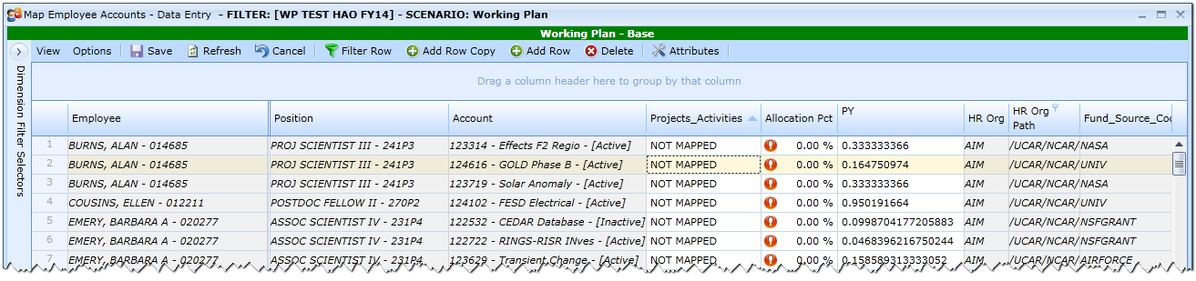

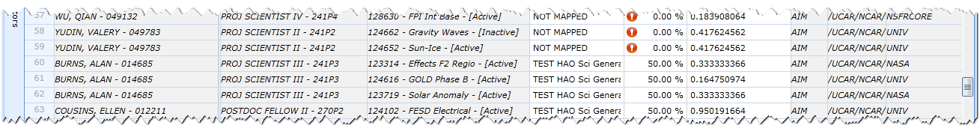

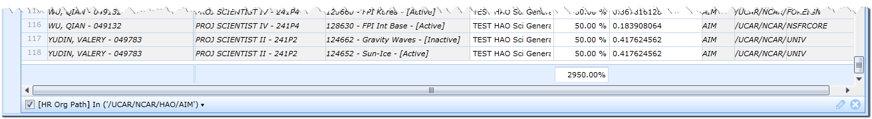

Select the first “NOT MAPPED” Entry and select “TEST HAO Mod General” from the Project / Activity List and enter 50% in the Allocation Column. **NOTE**- because the grid is sorted on Projects / Activities, as soon as I click off the new entry, “TEST HAO Mod General”, it sorts under Mapped and right above “TEST HAO Sci General” entries. Now that the Mod entry is in the list, select both “NOT MAPPED” and “TEST HAO Mod General” to make entry easier then copy the entry to all “NOT MAPPED” rows.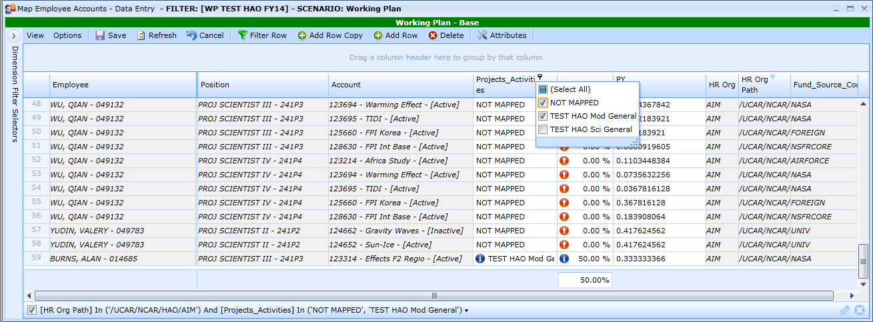

To keep this entry at the top before you copy, you can click the Project / Activity column header to sort in descending order.

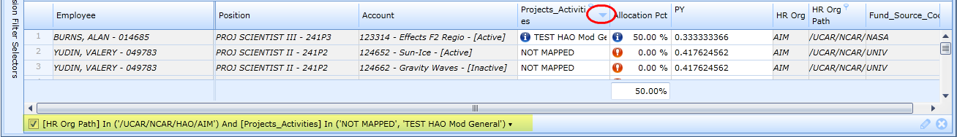

Copy these entries down through all the “Not Mapped” Entries and SAVE.

Open the filter on the Projects / Activities column header to select all. (You can click on “Select All” again; this no selection defaults to all, but takes the entry out of the filter.) Click on Employee to easily see the multiple entries:

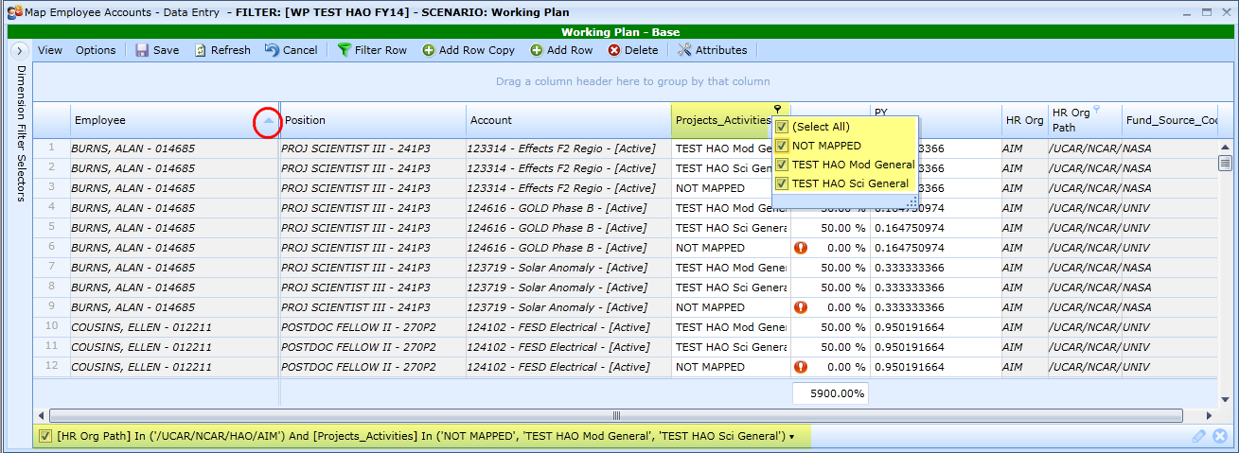

Because 50% was entered twice on each key, theoretically everyone in AIM should be fully mapped on every key to which they are assigned. To verify this for this group:

* Open the filter on Projects /Activities; click Select All to take the selections out of the filter – at this point the only filter is on HR Org Path and the AIM group.
* Drag the Employee Column Header to Group Panel
* Drag the Account Column Header to the Group Panel

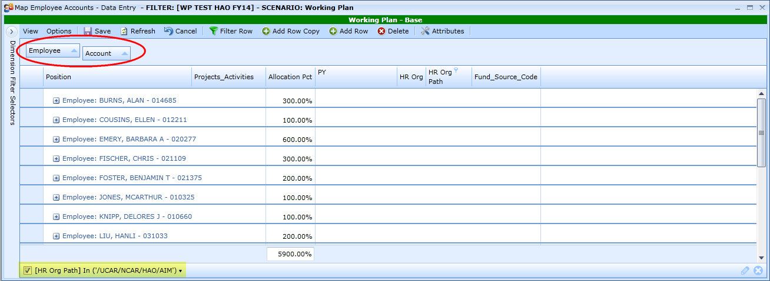

Click on the + sign on an employee to see the detail. Recall, each person is mapped 100 on each account key.

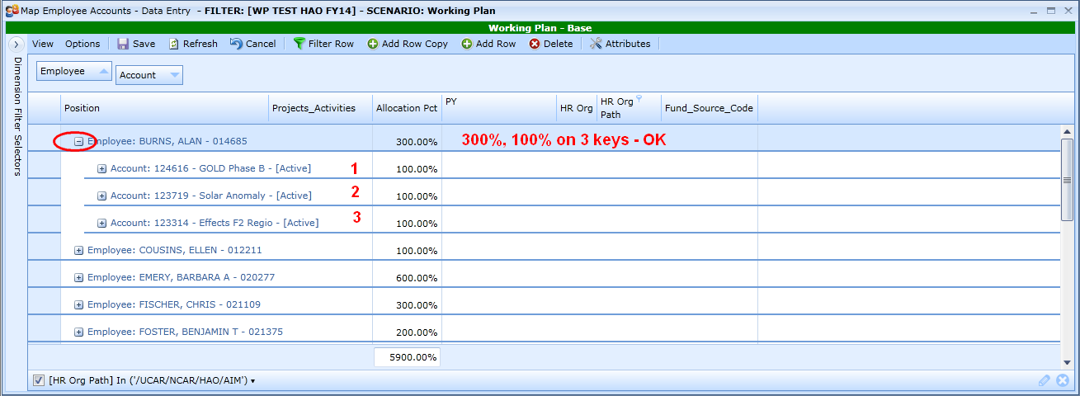

Ungroup the grid by right click on Account and select Ungroup and right click on Employee and select Ungroup. (This insures your column returns to the original location.)

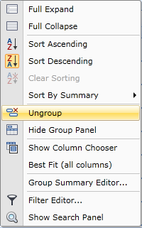

**Assumptions:** Recall Post Docs, Graduate Assts, Student Assts are mapped 100% to Education and staff outside of HAO are mapped as the group their key(s) fall under. The following continues within AIM.

Open the Filter on Position and select all job categories for Post Doc, Grad Asst and Student Asst.

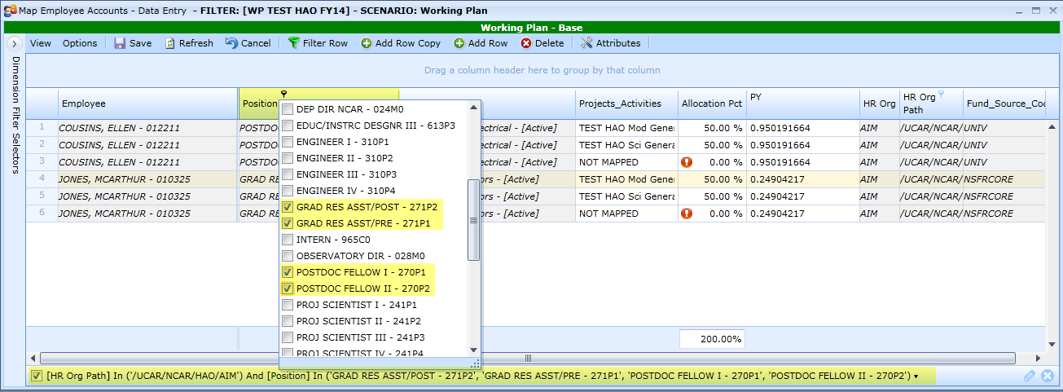

These are AIM staff so were mapped accordingly. To change these to “Education” delete the lines with their TEST HAO entries and **SAVE**.

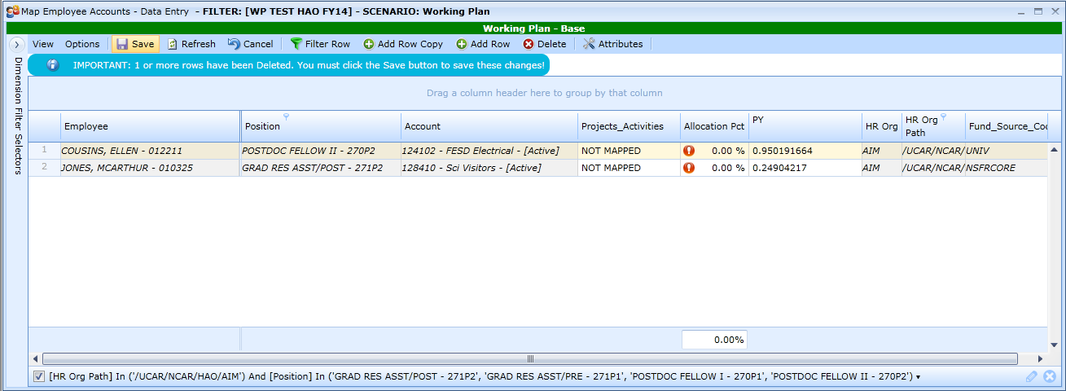

Select the first “NOT MAPPED” Entry and select “TEST HAO Ed General” from the Project / Activity List and enter 100% in the Allocation Column and copy the entry to the other row(s) and **SAVE**. These two folks in AIM are now mapped correctly

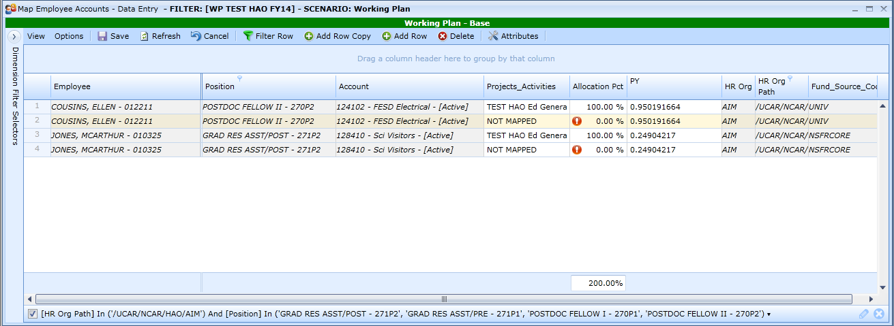

Open the filter on Position and Select All twice to remove this from the filter. Open the HR Org Path filter and select all items outside the Lab. NOTE - this takes away the AIM filter.

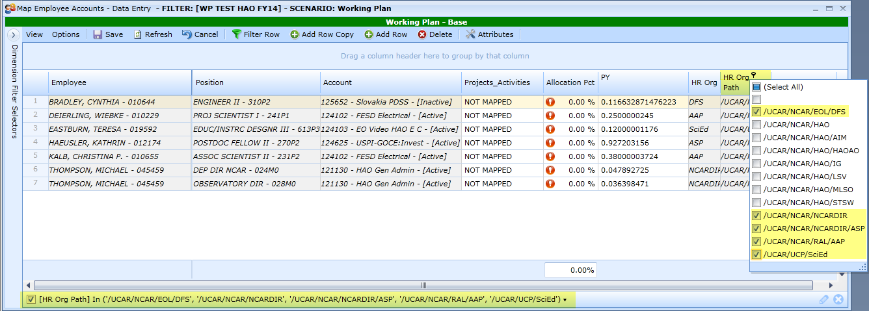

Account 124102 is an AIM key. Filter on Employee select those two employees on those keys to map as the AIM assumption, 50% Science, 50% Modeling

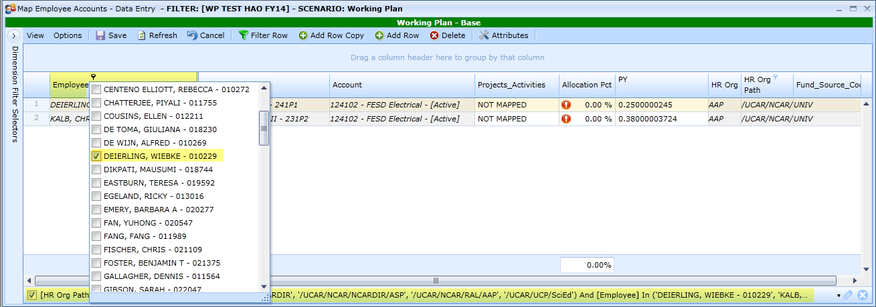

Select the first “NOT MAPPED” Entry and select “TEST HAO Sci General” from the Project / Activity List and enter 50% in the Allocation Column and copy the entry to the other row(s) and **SAVE**.

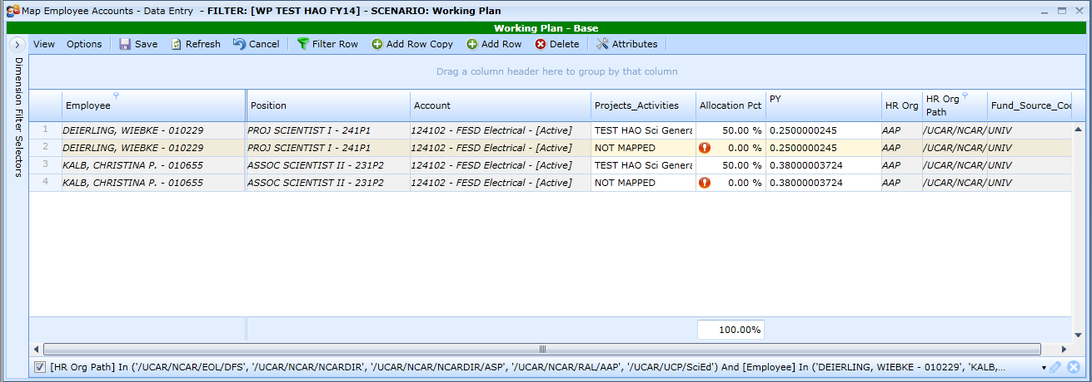

Click on the Projects Activities column header to sort items together. All “NOT MAPPED” are grouped and all the “TEST HAO Sci General” are grouped.

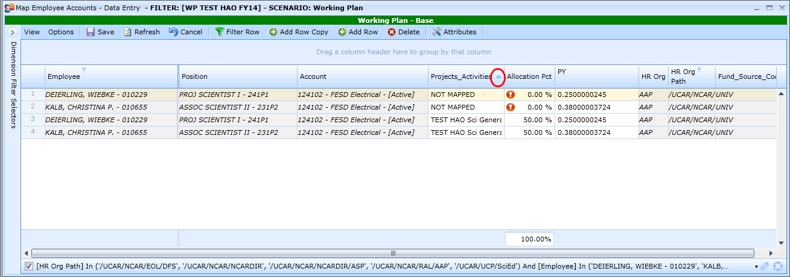

Select the first “NOT MAPPED” Entry and select “TEST HAO Mod General” from the Project / Activity List and enter 50% in the Allocation Column. **NOTE**- because the grid is sorted on Projects / Activities, the new “TEST HAO Mod General” entry, which was on the first line, sorts under Mapped and right above “TEST HAO Sci General” entries.

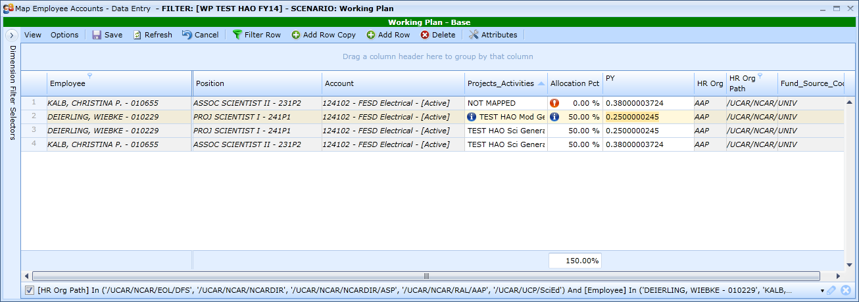

Since there are so few entries, skip the earlier additional steps shown on the 59 lines above. Copy the new items in line 2 to line 1 and save. Both non-Lab employees are now mapped at 100% on this key.

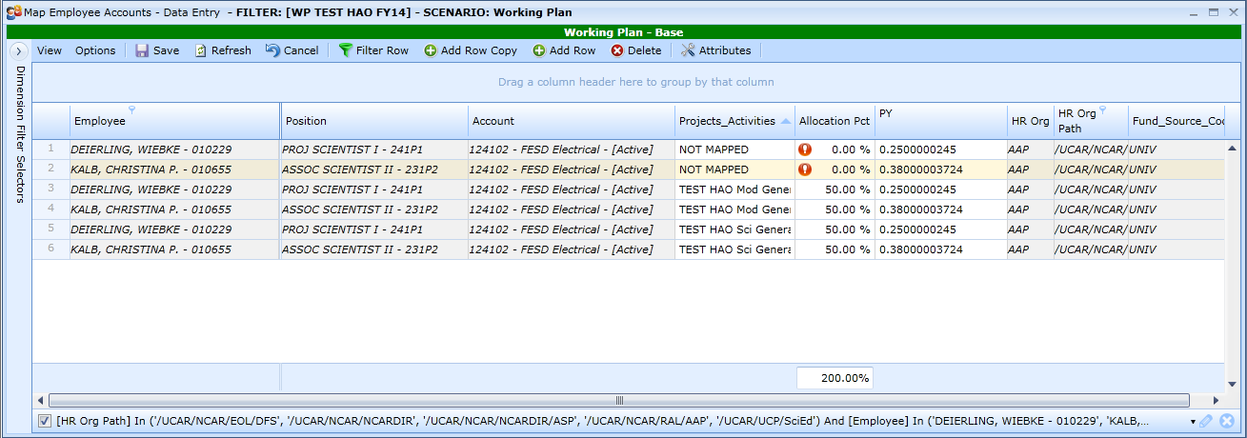

Clear the Entire Filter at the right bottom of the grid.

