**Examples of Filtering for Mapping to Streamline Data Entry -**

**Map Non-Salary to Projects or Activities Data Entry Grid**

Note in this example the grid has 94 lines, (94 keys with planned Non-Salary Expenses). Again, filtering, sorting and copying make data entry much simpler.

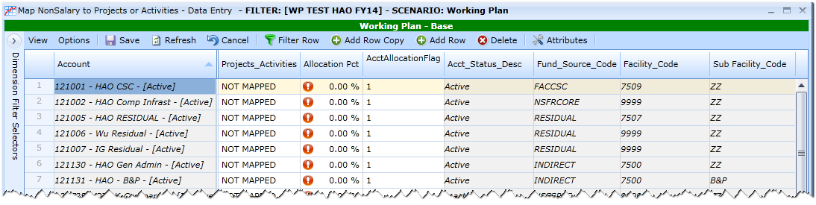

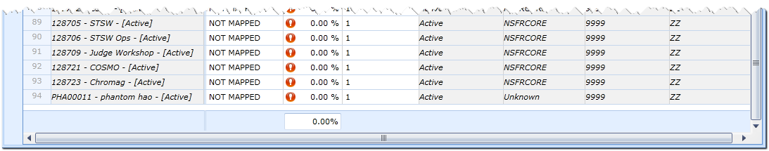

Upon opening the Grid all keys show up as “NOT MAPPED”. When you enter a Project / Activity in the NOT MAPPED line and save, the system creates a new record; there will be a line for the added item and the line for “NOT MAPPED” to allow additional data entry without Add Row Copy. The sorting examples below show how to simplify data entry while multiple lines are shown.

On this grid, mapping keys with Non-Salary Expenses, the filtering takes place on Account Key

**Assumptions for Sorting / Filtering to Map Non-Salary Projects / Activities and Percentages**

* Directorate Keys are similarly mapped, 50% to Admin, 25% to Science and 25% to Modeling

Select Directorate Keys via the Column Filter:

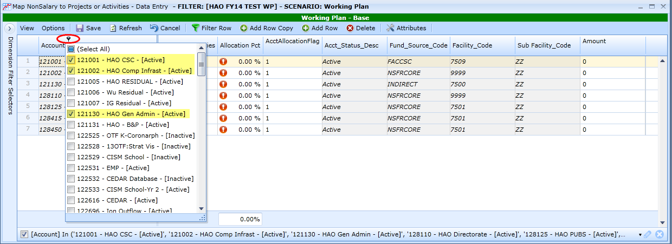

For the first row, select “Test HAO Admin” from the Project / Activity List and enter 50% in Allocation %.Copy these entries down to the other keys. Both columns can be copied at the same time.

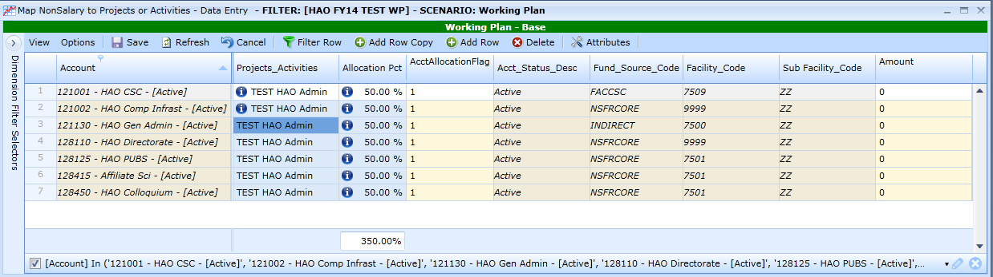

Save the entries. Notice the new entries and “NOT MAPPED” for each key.

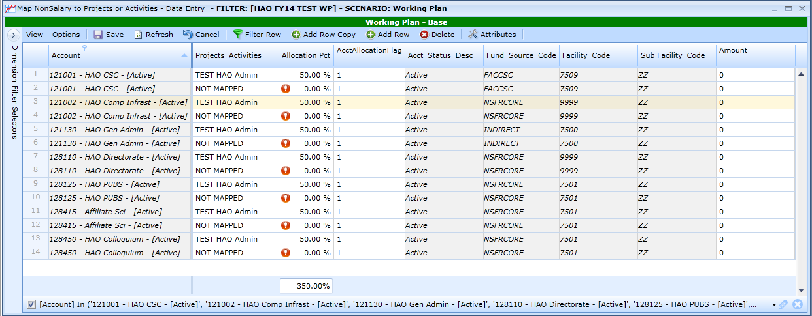 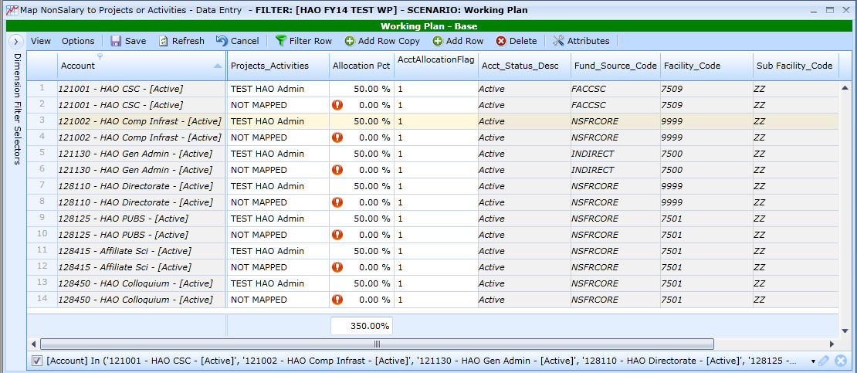

Click on the Projects Activities column header to sort items together.

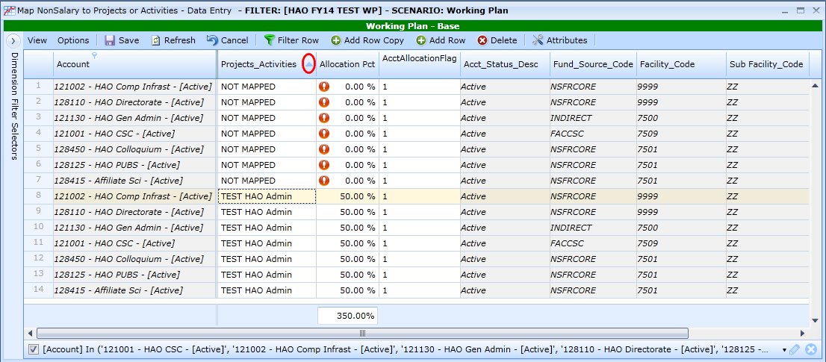

For the first row for “NOT MAPPED”, select “Test HAO Sci General” from the Project_ Activity List and enter 25% in Allocation %. Copy these entries down to the other keys. NOTICE – when I clicked to copy, the Project / Activity column sorted and the first entry that I copied from went to the bottom.

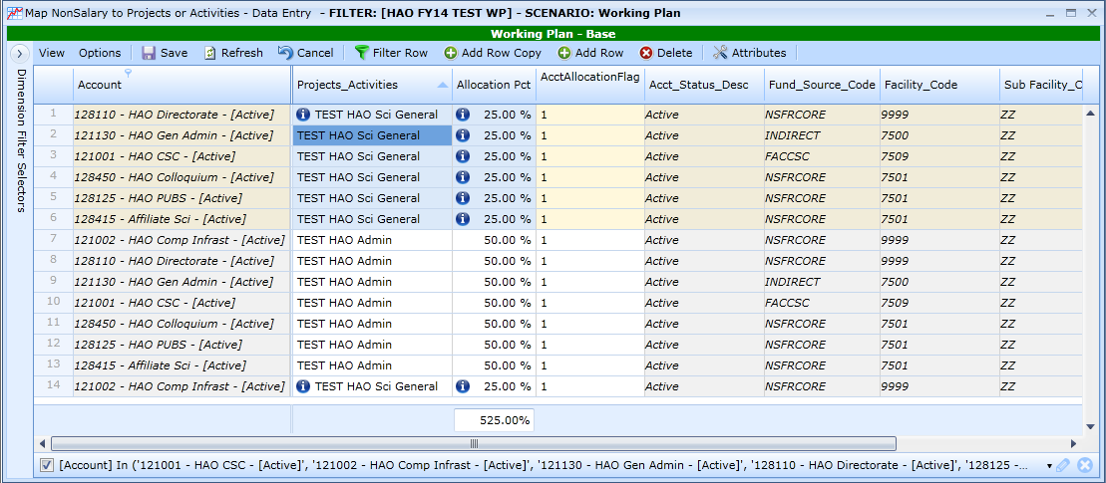

Save the entries. Notice you now have the new entries and “NOT MAPPED” for each key. NOTICE – there are now two areas mapped AND “NOT MAPPED”. Since I had sorted on Projects / Activities before this save, these remain sorted in this way.

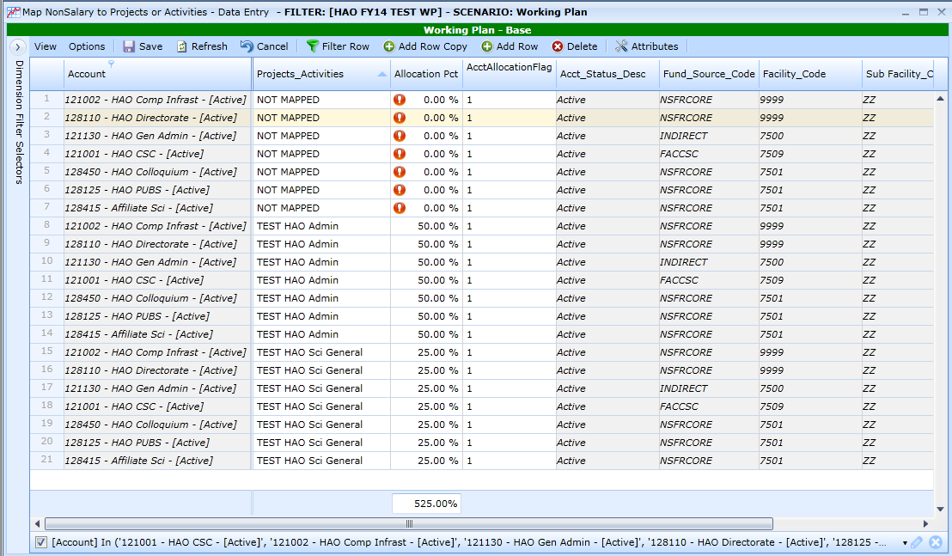

For the first row for “NOT MAPPED”, select “Test HAO Mod General” from the Project / Activity List and enter 25% in Allocation %. Copy these entries down to the other keys. NOTICE – when I clicked to copy, the Project / Activity column sorted and my first entry that I copied from went to the middle of the list.

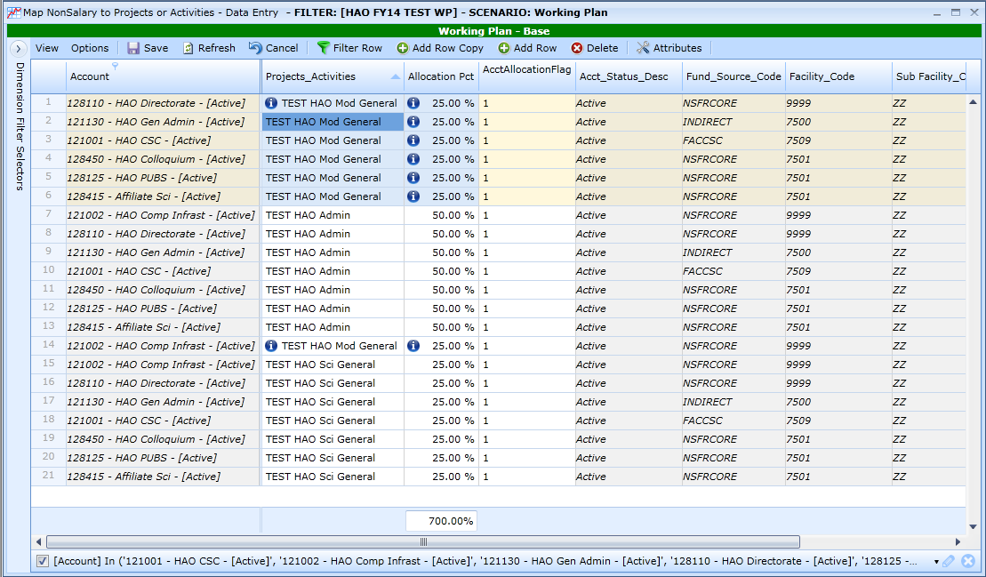

Save the entries. Notice you now have the new entries and “NOT MAPPED” for each key. NOTICE – I now have the three areas mapped AND “NOT MAPPED”. Since I had sorted on Projects / Activities before this save, these remain sorted in this way.

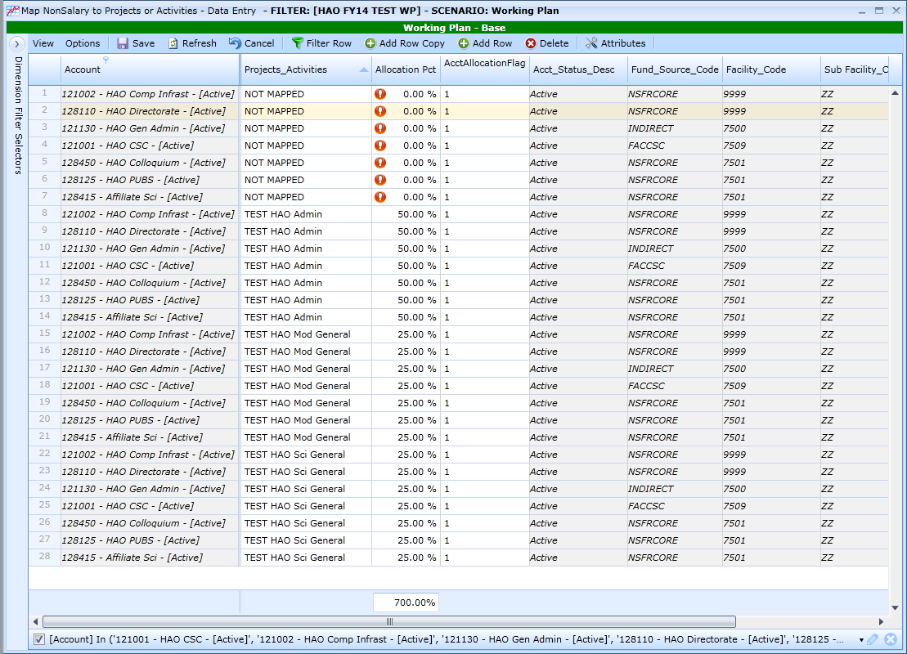

Clear the Entire Filter at the right bottom of the grid.

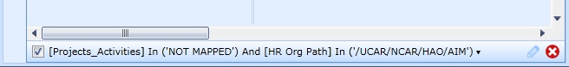

**Assumptions for Sorting / Filtering to Map Non-Salary Projects / Activities and Percentages**

* Operations Keys within Sections / Groups are similarly mapped
  + Instrumentation Group is 100% Instrumentation
  + AIM Group is 50% Science, 50% Modeling
  + STWS Group is 75% Science, 25% Modeling
  + LSV Group is 100% Science

Select All Keys associated with the Instrumentation Group via the filer on the Column Header. For the first row, select “Test HAO Inst General” from the Project / Activity List and enter 100% in Allocation %.

Copy these entries down to the other keys.

**NOTICE** – When I put in the % first and did not change Project / Activity before saving, it did save, but I got an error message. (If I had not caught it now, it would have shown up easily in the verification processes.) Since I caught this, I entered and saved 0% to these and started again. If I typed the correct Project / Activity in the “NOT MAPPED” cell without making that change, I would end up with both that entry AND these “NOT MAPPED” at 100.

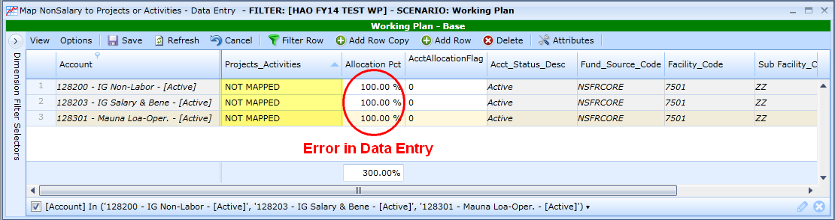

After changing the “NOT MAPPED” to “0” and saving, I selected “Test HAO Inst General” from the Project / Activity List and enter 100% in Allocation % and copied these entries down to the other key. Notice the new entries and “NOT MAPPED” for each key.

