**Examples of Filtering for Mapping to Streamline Data Entry -**

**Map Projects or Activities to Strategic Plan Items Data Entry Grid:**

Note in this example the grid has 108 lines, (18 Projects / Activities X 6 Strategic Plan Items). Filtering. sorting and copying make data entry much simpler.

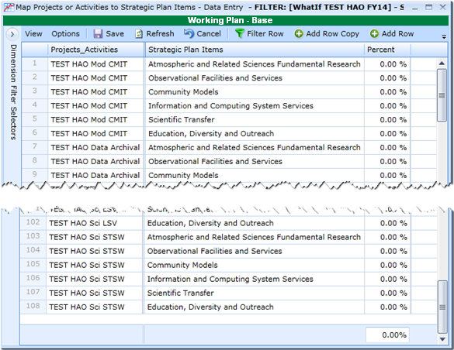

**Assumptions for Sorting / Filtering to Enter Strategic Plan Percentages**

* All Projects / Activities with “inst” are 100% Facilities
* All Projects / Activities with “sci” are 100% Fundamental Research
* All Projects / Activities with “ed” are 100% Education
* All Projects / Activities with “mod” are 80% Modeling, 20% Fundamental Research
* All Projects / Activities Data Archival is 25% Modeling, 25% Facilities, 50% Computing
* All Projects / Activities with “admin” are 30% Modeling, 30% Fundamental Research, 30% Facilities, 10% Education

**FIRST** - Filter for all items at 100%, this includes “inst” or “sci” or “ed”

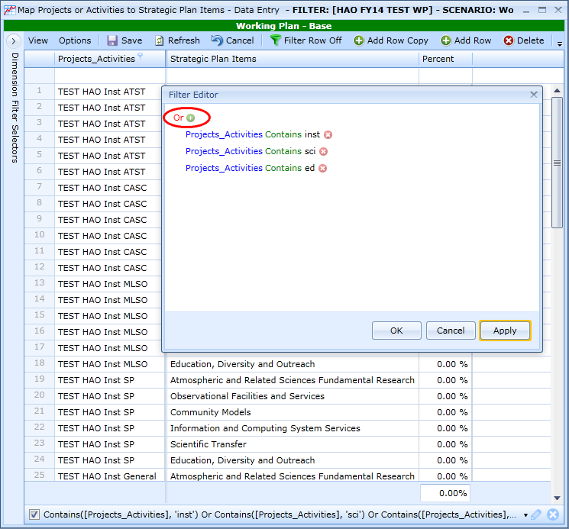

Filter for just Facilities in Strategic Plan Items, which apply to the “inst” lines.

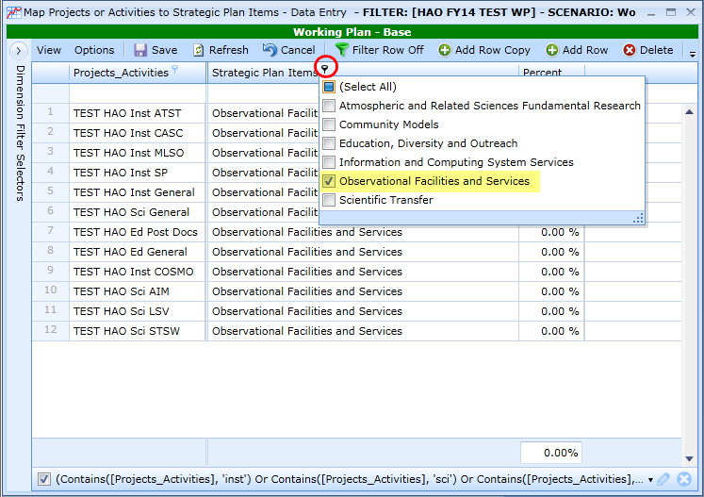

Make sure Priorities are sorted in ascending order; this will place instrument entries together, science entries together and education entries together.

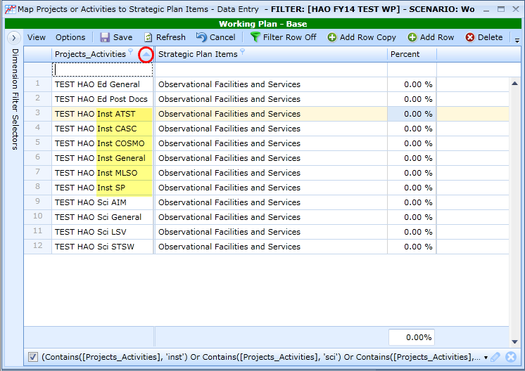

For the first Instrument Project / Activity enter “100” and copy down and SAVE.

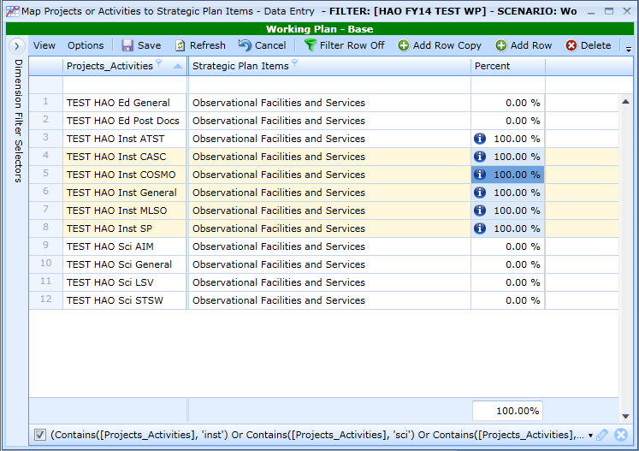

Filter only on Fundamental Research under Strategic Plan Items which applies to the “sci” lines; make sure other items are not checked.

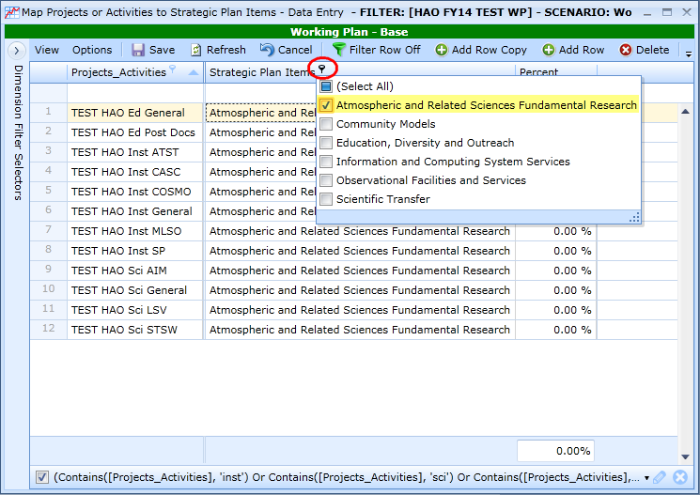

Make sure Priorities are sorted in ascending order. For the first Science Project / Activity enter “100” and copy down and SAVE.

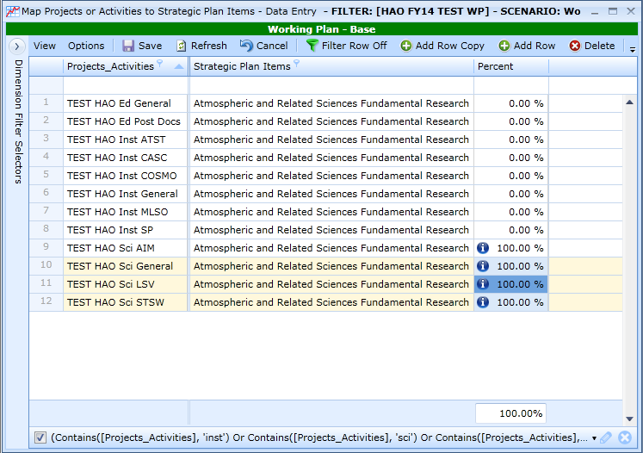

Filter only on Education under Strategic Plan Items which applies to the “ed” lines; make sure other items are not checked.

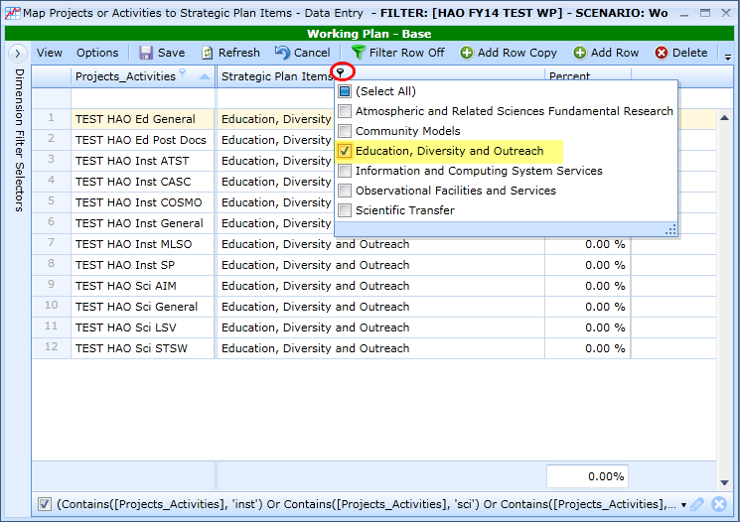

Make sure Priorities are sorted in ascending order. For the first Education Project / Activity enter “100”, since there is only one more line, enter “100” in the second one as well and save.

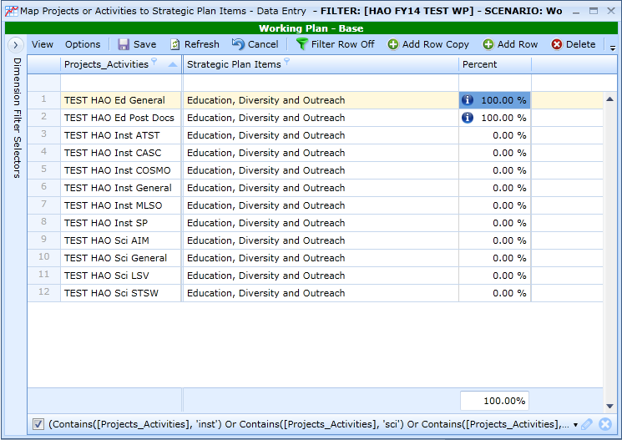

Clear the Filter on the grid.

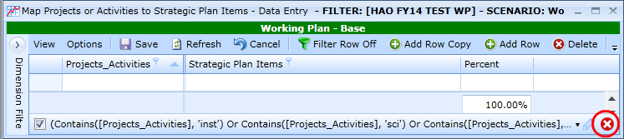

To see what’s been mapped so far, select 100% from the Percent Column:

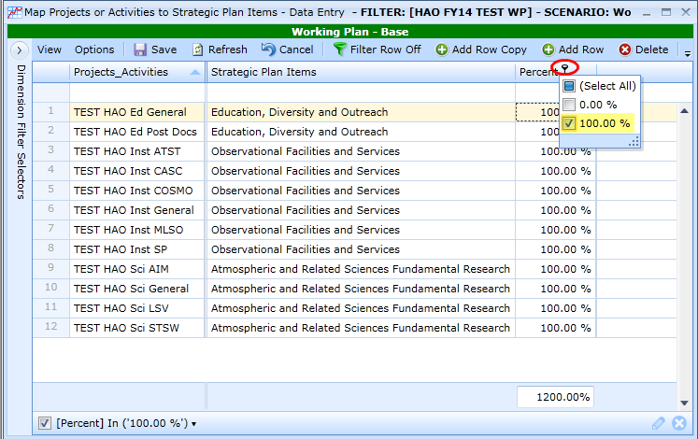

Clear the Entire Filter at the right bottom of the grid.

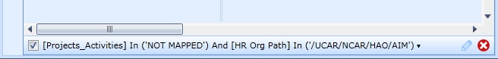

**SECOND** – Filter for all modeling projects. Recall that these projects are 80% Modeling, 20% Fundamental Research.

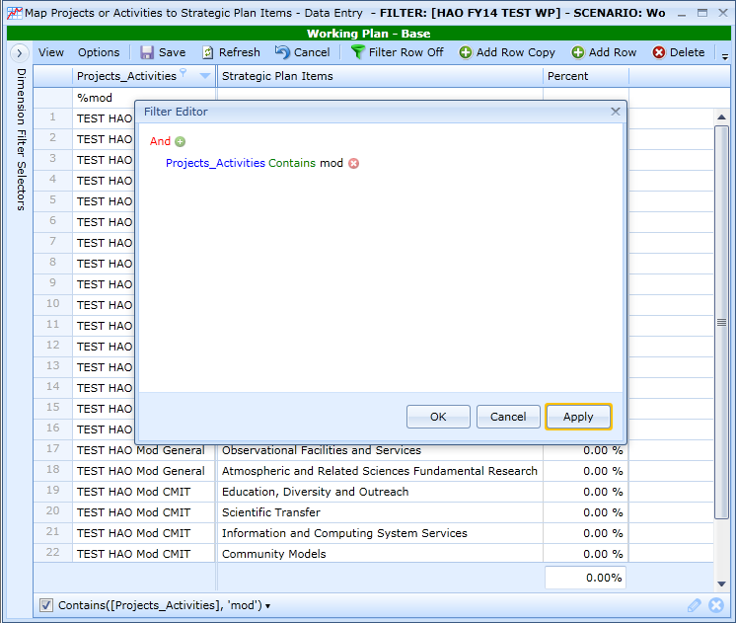 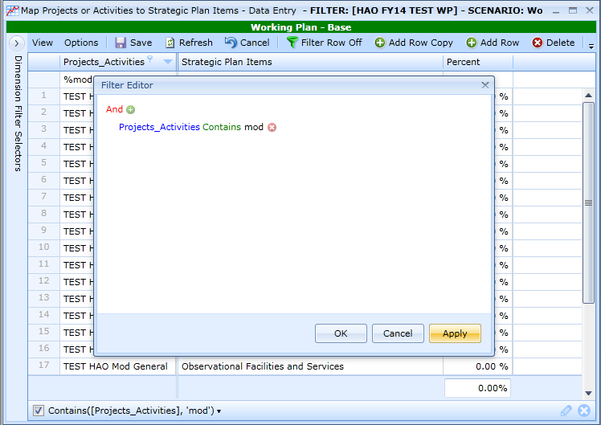

Filter for only Fundamental Research and Community Models in Strategic Plan Items since these are the only two Strategic Plan items to which these apply. This takes the visible list for data entry from 24 to just 8 items.

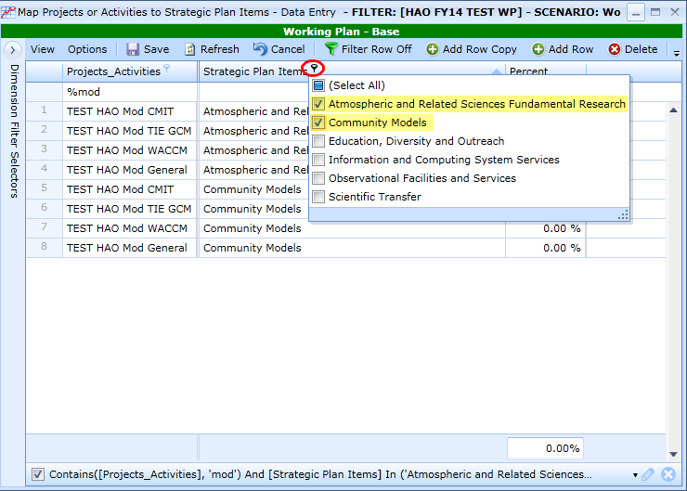

Make sure Strategic Plan Items are sorted in ascending order. Enter 20% in the Fundamental Research Lines and enter 80% in the Community Models Lines and SAVE.

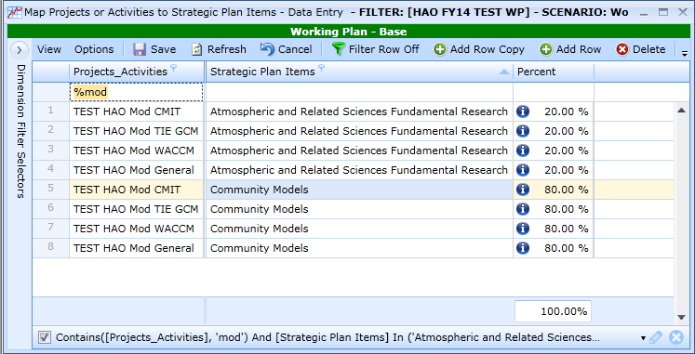

Clear the Entire Filter at the right bottom of the grid.



**THIRD** – Filter for all data archival projects. Recall these projects are 25% Modeling, 25% Facilities, and 50% Computing

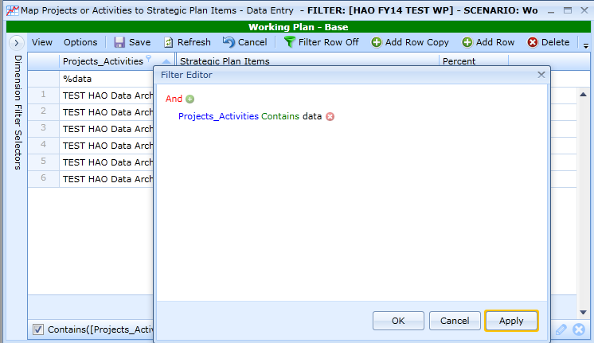

Since only one Project / Activity is identified there is no need to filter further. Enter “50” in Community Models, “25” in Observational Facilities and “25” in Information and Computing System Services and SAVE.

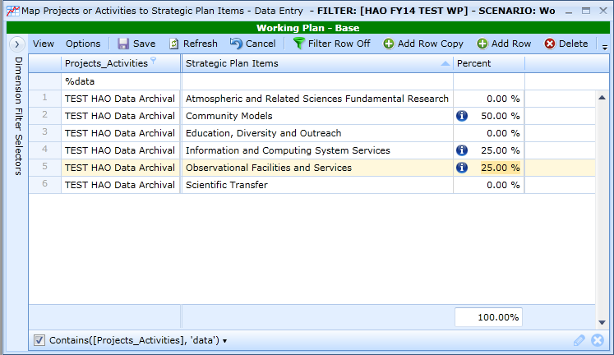

Clear the Filter on the grid.

To see what’s been mapped so far, select all but 0% from the Percent Column:

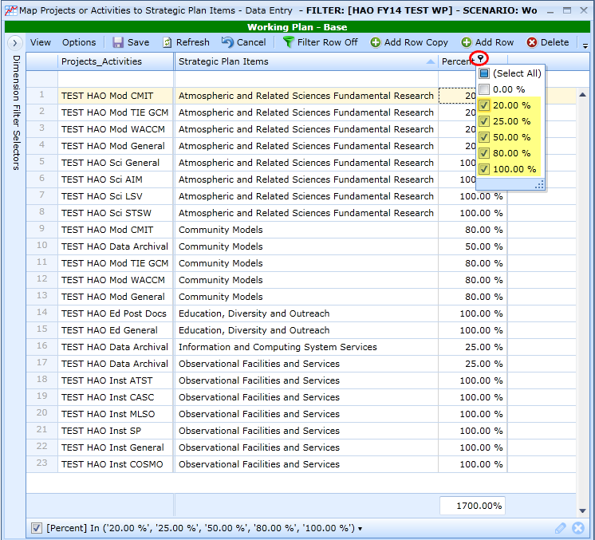

**FOURTH** – Filter for all HAO Admin projects. Recall these projects are 30% Modeling, 30% Fundamental Research, 30% Facilities, 10% Education

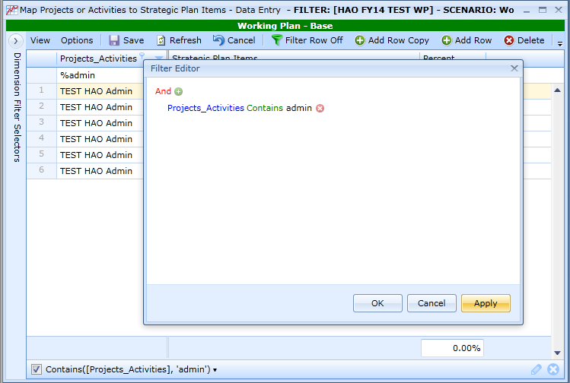

Since only one Project Activity is identified there is no need to filter further. Enter “30” in Community Models, “30” in Fundamental Research, “30” in Observational Facilities and “10” in Education, Diversity and Outreach and SAVE.

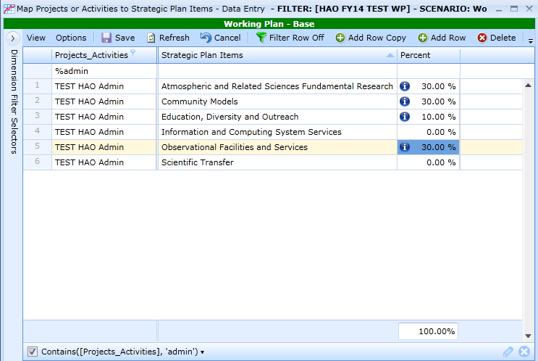

Clear the Filter on the grid. Make sure Priorities are sorted in ascending order and select all Percentages but “0” to see the full mapping of the 17 lines out of the possible 108 lines.

