**Examples of Filtering for Mapping to Streamline Data Entry -**

**Assign Project or Activity to Priority and Ranking Data Entry Grid:**

**Assumptions for Sorting / Filtering to enter Priorities**

* All Projects / Activities with “MOD” in the name are under Community Modeling
* All Projects / Activities with “SCI” in the name are under Scientific Research
* All Projects / Activities with “INST” in the name are under Instrumentation
* All Projects / Activities with “ED” in the name are under Education

Use Filter Editor to select only those items that include (contain) “MOD”

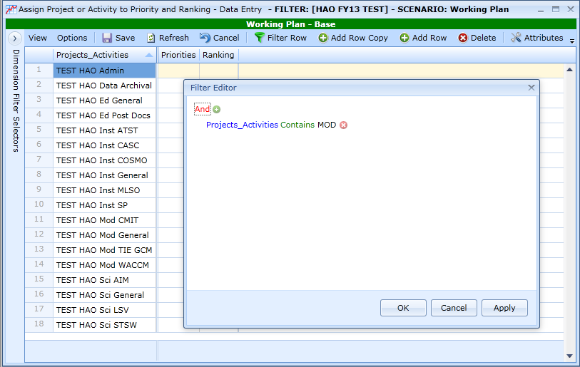

Filtering on “Contains “MOD”” has only the following Projects / Activities listed.

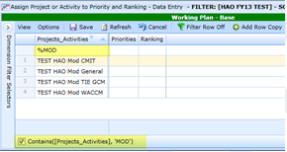

Select “TEST HAO Community Modeling” from the Dropdown List:

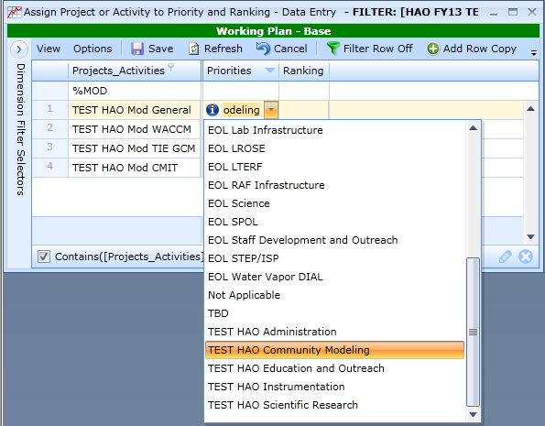

Click off the cell and click on the text so what you want to copy is highlighted:

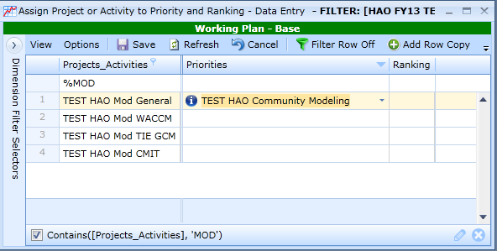

Use either Ctrl-C to copy or Right Click to copy the selection

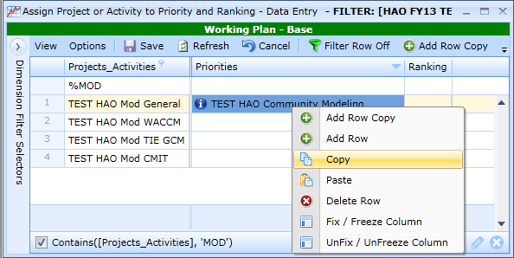

**NOTE**

The first time you copy in a session, you wil be asked if you want the Web Application to have access to your clipboard, Select “yes” to continue. To avoid this in every new session, check “Remember my answer”.

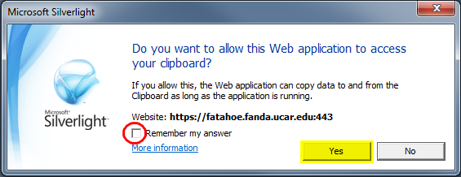

Highlight the cells you wish to copy to:

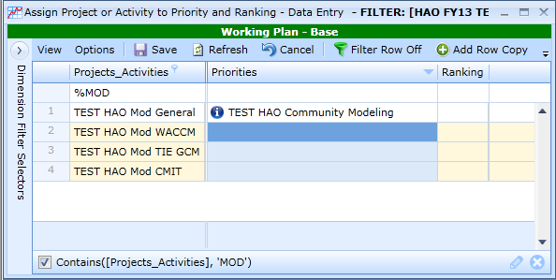

Use either Ctrl-V or Right Click to Paste the selection to the cells

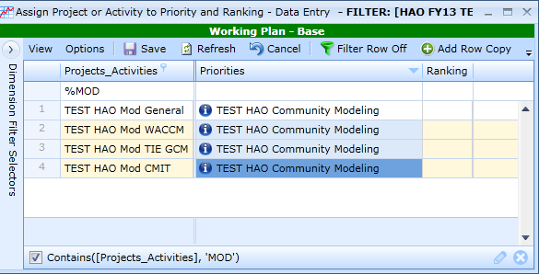

Note, in copying to multiple cells, the may not always show on each cell.

Save  and see the entry is now copied to multiple cells:

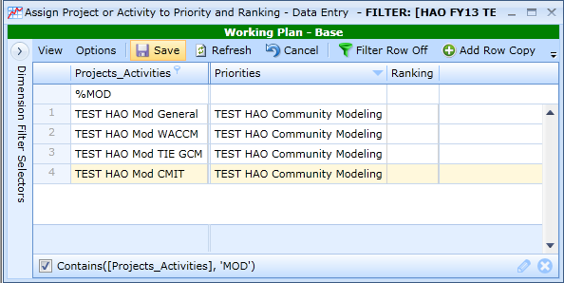

Clear the Overall Filter so all Projects / Activities are listed.



**Assumptions for Sorting / Filtering to Enter Ranking**

* “TEST HAO Community Modeling” and “TEST HAO Scientific Research” are ranked “1”
* “TEST HAO Instrumentation” is Ranked “2”
* “TEST HAO Education and Outreach” is Ranked “3”
* “TEST HAO Administration” is Ranked “4”

Filter on the Priorities column to select only these two Priorities from the Dropdown List:

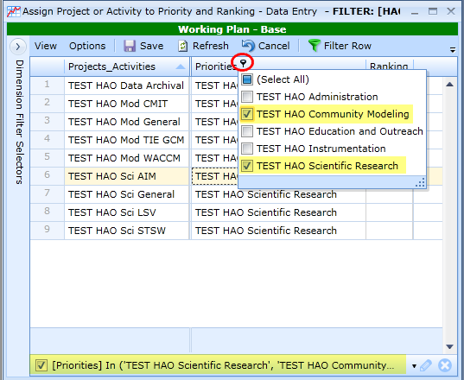

Select “1” from the dropdown list:

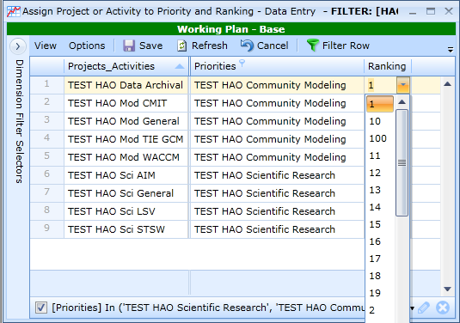

Click off the cell and click on the text so what you want to copy is highlighted:

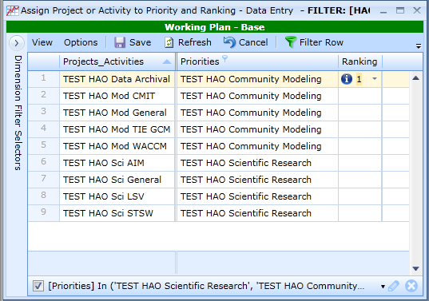

Use either Ctrl-C to copy or Right Click to copy the selected text and then highlight the cells you wish to copy to:

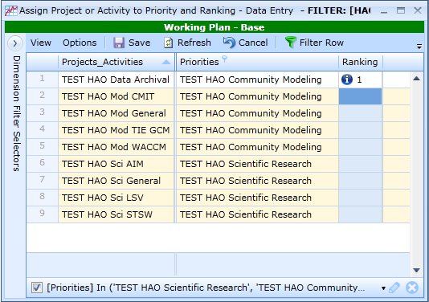

Use either Ctrl-V or Right Click to Paste to the cells

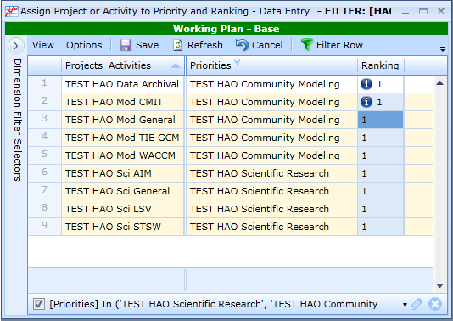

Save  and see the entry is now copied to multiple cells:

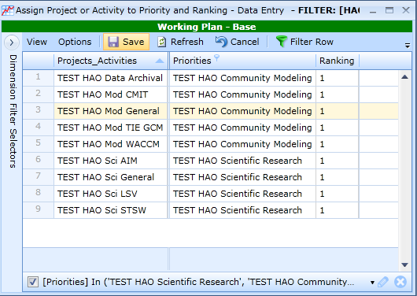

By clearing the Overall Filter, this simple example shows how non-contiguous rows were easily identified with filtering above. Imagine entering this without filtering for a list of 50 or more Projects / Activities.

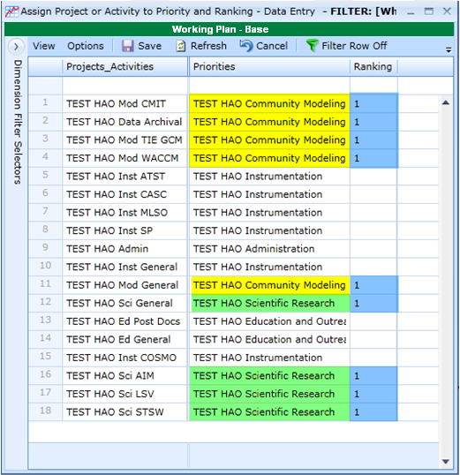

Recall the earlier assumptions: “TEST HAO Instrumentation” is Ranked “2”, “TEST HAO Education and Outreach” is Ranked “3” and “TEST HAO Administration” is Ranked “4”

Due to the specific creation of the Project / Activity names, these easily sort priorities together to support data entry. Sort on the Priorities column to group like entries together and where there are multiple entries, Copy/ Paste can be used.

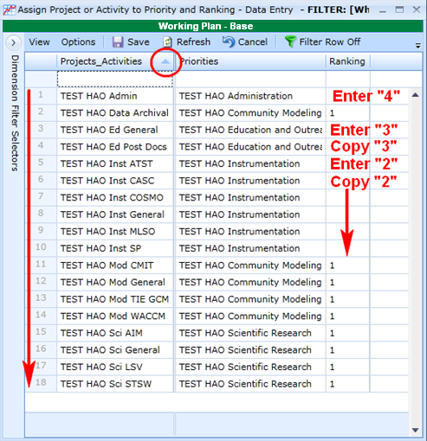

**Alternative Assumption** - all other entries are ranked “2”:

Sort on the Ranking column to group all empty cells together, and then enter “2” in the first cell and Copy / Paste to the remaining cells.

