**Sorting, Grouping, Filtering Reference with Mapping**

Sorting, Grouping and Filtering are ways to streamline and simplify Data Entry, particularly in the Mapping Tool.

**Please note:** these are not static and apply only to the grid while it’s open, you cannot save these filters; they are meant to be used dynamically as you are planning.

There are several ways to sort, group and filter in the grids to view more precise selections:

* **Sorting and Grouping**
  + Sort by Columns
  + Group by Column Header(s) in the Group Panel
* **Filtering**
  + Filter with Filter Row by typing the selection, which is essentially “starts with”
  + Filter on a column header(s) by selecting or unselecting specific items within the column
  + Create or edit a Filter in the Filter Editor which includes “and”, “or”, “begins with”, “ends with”, “contains”, “does not contain”…
  + Clearing, Disabling or Editing Filters

**Sort by Columns**

**Sort by a column:**

* Option 1 - Left Click on the column header to sort by that column, either ascending or descending order.





* Option 2 - Right Click on the column header to see the menu and select either “Sort by Ascending” or ‘Sort by Descending” to sort the grid on that column.

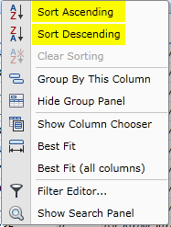

**Group by Column Header in the Group Panel**

**Group Panel**

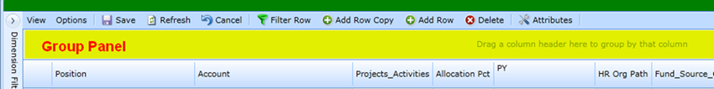

**Verify the Group Panel is shown or hidden:**

* Right Click any Column Header to see the Menu
* If the Group Panel is shown, selection option is “Hide Group Panel”
* If the Group Panel is hidden, selection option is “Show Group Panel”

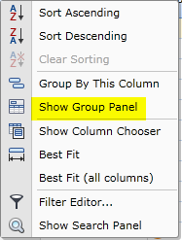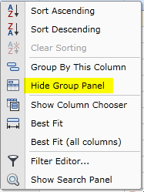

**Group by a column:**

* Option 1 – Left Click on the Column Header and drag it onto the Group Panel

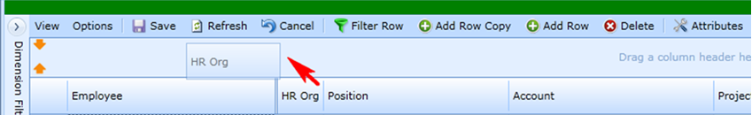

* Option 2 – Right Click on the Column Header and select “Group By This Column” from the menu

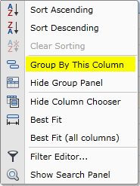

**Grouping by Column Example:**

The TEST grid for Mapping Employee Accts has 169 lines with keys assignments for 54 employees.

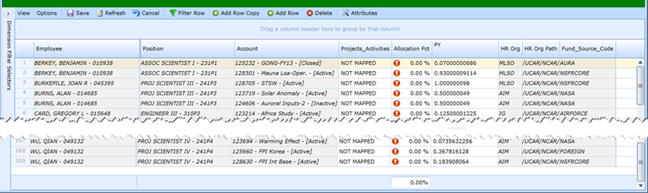

Grouping by HR Org results in 9 rows, a summary row for each group.

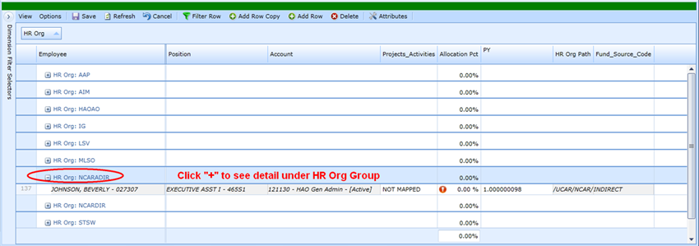

**To see detail for a single Group:** Click on the “+”.

**To collapse a Group:** Click on the “-“.

**See detail for ALL Groups:** Right Click HR Org Column Header, select “Full Expand” from the menu

**Hide all detail:** select “Full Collapse”

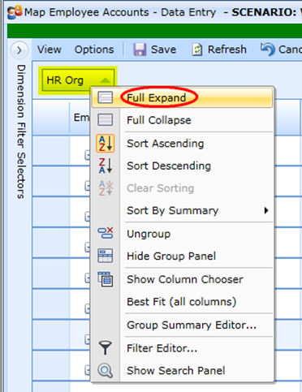

**Ungroup insures the column returns the original location:** Right Click HR Org Column Header and select “Ungroup” from the menu.

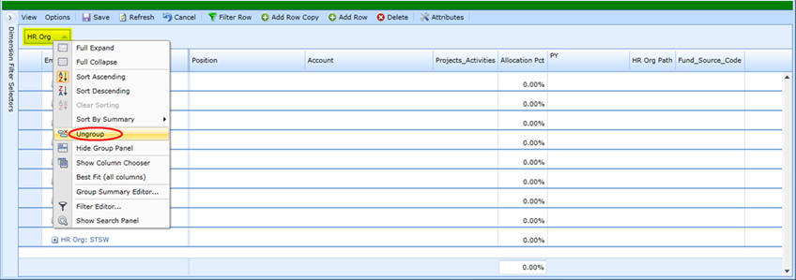

**Grouped by Employee, Sort by Job Title Example**

Easily see there are two job titles

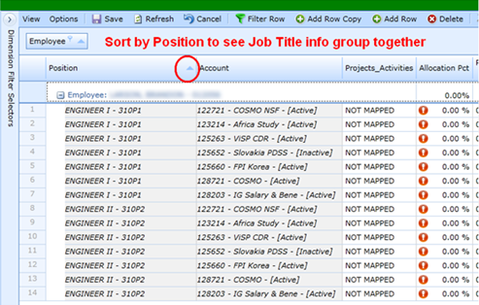

**Grouped by Employee, Sort by Acct Key Example**

Easily see all instances on a single key

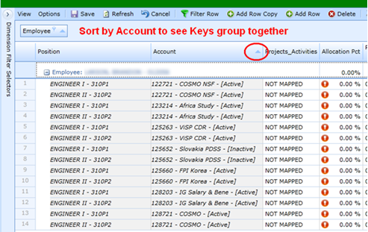

**Filter with Filter Row**

On the Grid Selections, “Filter Row” toggles with “Filter Row Off”, “Filter Row” shows the filter row and “Filter Row Off” hides the filter row.

**Filter with Filter Row:**

* Select “Filter Row” to see the blank filter row on the top of your grid
* Begin typing to filter. Filtering works via “starts with”

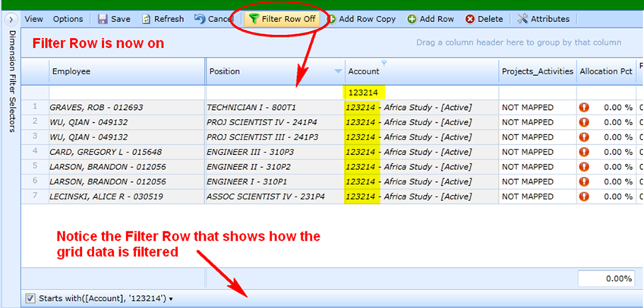

**Filter Row can be applied to multiple columns:**

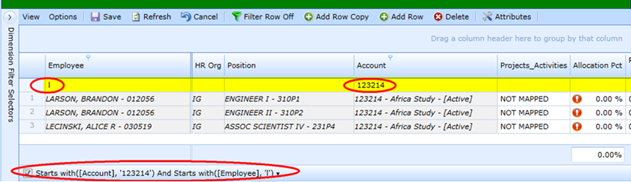

**Selections in the Filter Row apply even if it is not showing:**

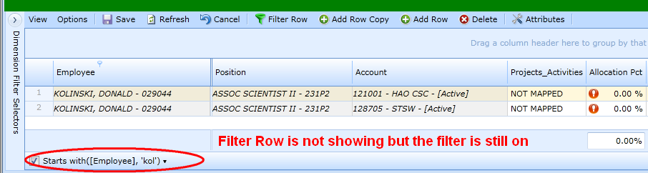

**Filter on Column Header**

**Filter on a column:**

* Hover over the Column Header and click on the Filter Icon,  to see the dropdown list of all unique items in the column. Select items you wish to view.

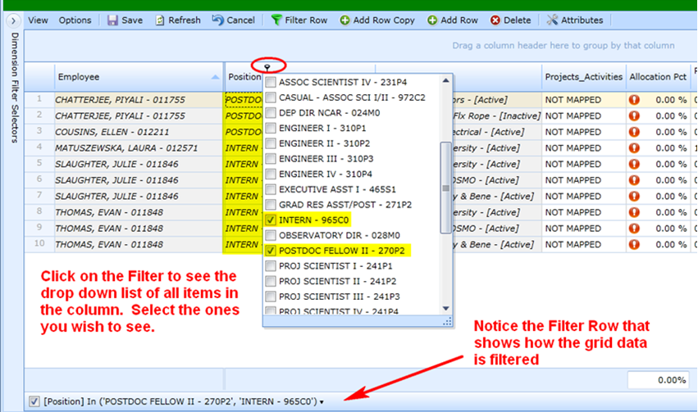

**Filters can be applied to more than one Column Header:**

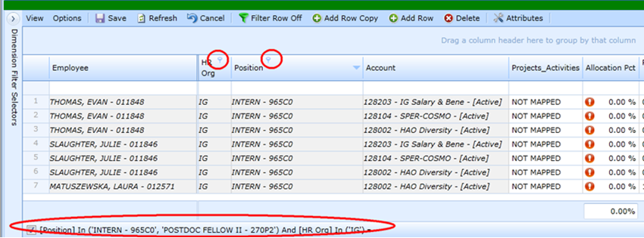

**Filter Editor**

The Filter Editor provides more than just the “starts with” of the filter row. It includes “and”, “or” operators as well as “begins with”, “ends with”, “contains”, “does not contain” and other options.

**Open the Filter Editor:**

* Right Click any Column Header to see the Menu
* Select Filter Editor

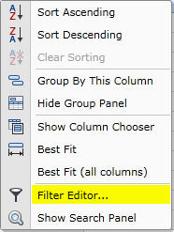

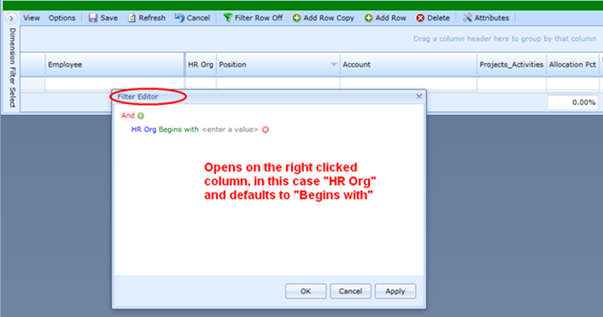

**Options:**

To change the column, click on the current one listed to see dropdown list of columns from the grid:

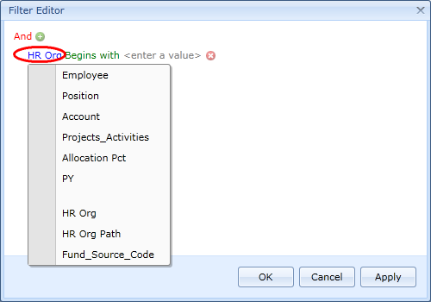

To change the filtering, click on the current filter to see the dropdown list of options:

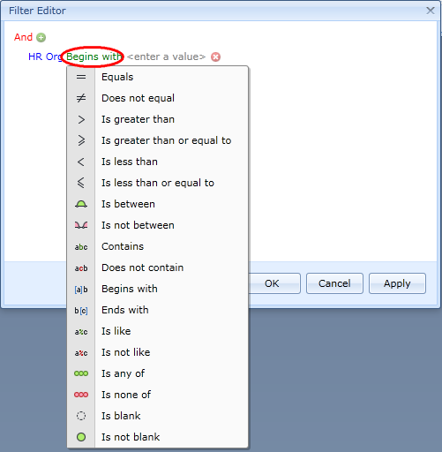

To enter the value to filter on, click on “Enter a Value” to either begin typing or to select from the dropdown list associated with the unique entries in the column.

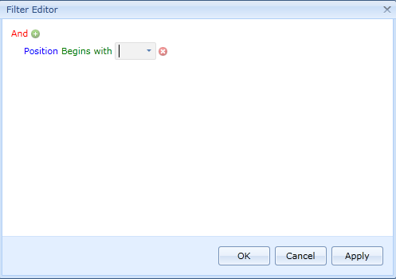

* **Tab off the value after your entry is complete**. If you do not tab off, it will not make the selection and will appear as if there are no matches.

**Edit / Create a Filter:**

* Click on ”HR Org” and Select Employee
* Click on “Begins With” and Select Contains
* Click on “Enter a Value” and type value (*this is not case sensitive*)
* **\*\*** Tab off the entry ** (If you don’t tab off, it won’t make the selection and looks as if there are no matches)
* Click Apply to see the selection
* Click OK to close the filter editor

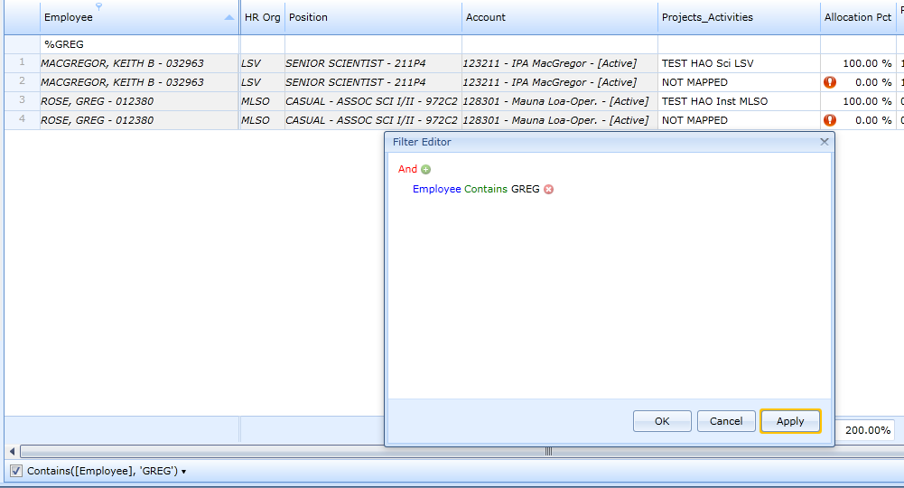

Note this filter selects any employee with “greg” in the name.

**The filter can include multiple items:**

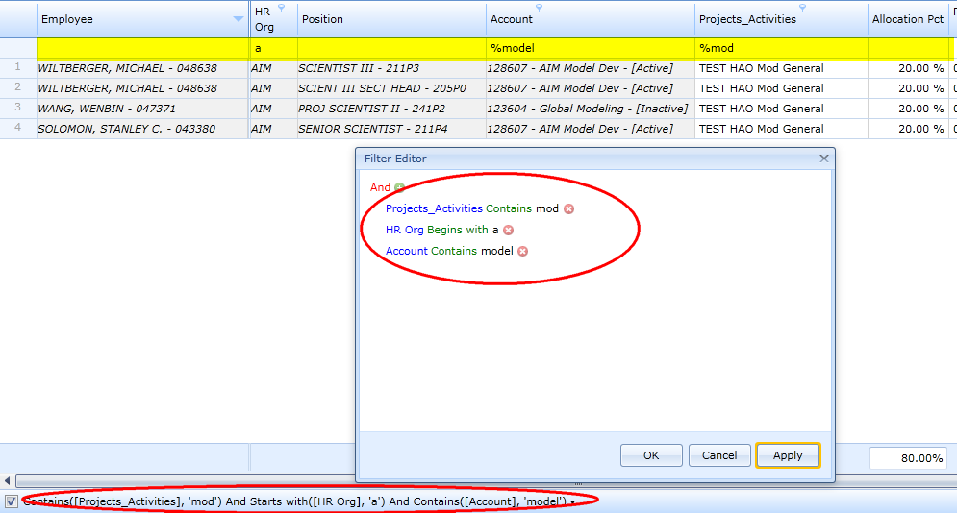

Note this filter selects all Project Activities that contain “mod” in the name ***and*** all HR Org’s beginning with “a” ***and*** all Accounts that include “model” in the name. Notice how the Filter Row and the bottom o the grid has been filled in.

**Multiple filters / conditions can include AND / OR and other logic:**

Click on “And” to see the drop down list of options

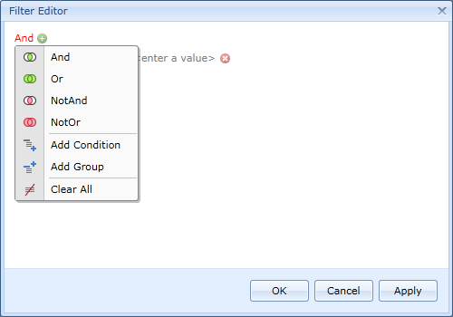

**Add filters or new conditions:**

Click the Plus Sign to add another row and edit as necessary

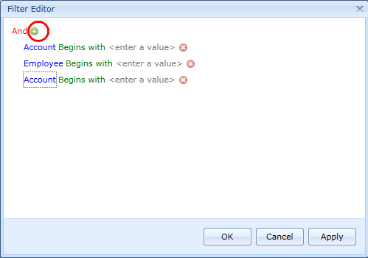

**NOTE**

**If you think you may be missing information in a grid, check the Filter Row and the Filter Bar at the bottom of your grid to determine if any filters are on.** When you change dimensions, filters can remain on, but hidden until you turn on the filter row.

**Also check the filter symbol**  will show on any columns on which the grid is filtered.

**Clearing, Disabling or Editing Filters**

Clear / Delete the entire filter from the Filter Bar:

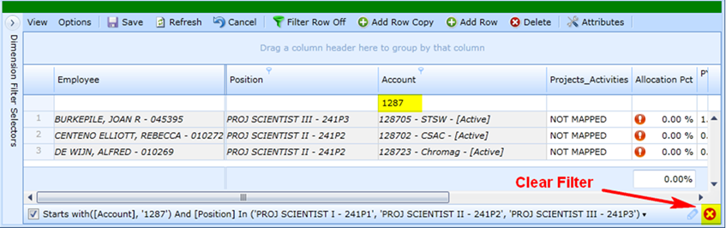

Note you can also delete “1287” from the Filter Row, but that will delete only the first portion of the filter, “Starts with (Account)…” and the Project Scientist selections will remain.

Disable the filter:

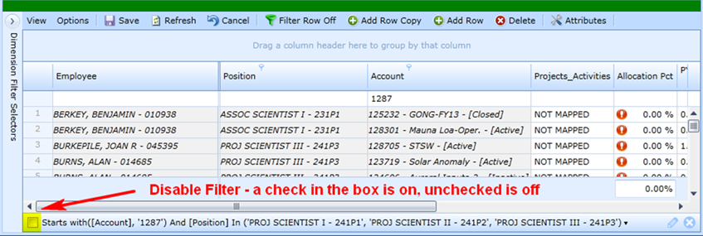

Note the additional lines now showing compared to just three above.

Edit Filter from the Filter Bar:

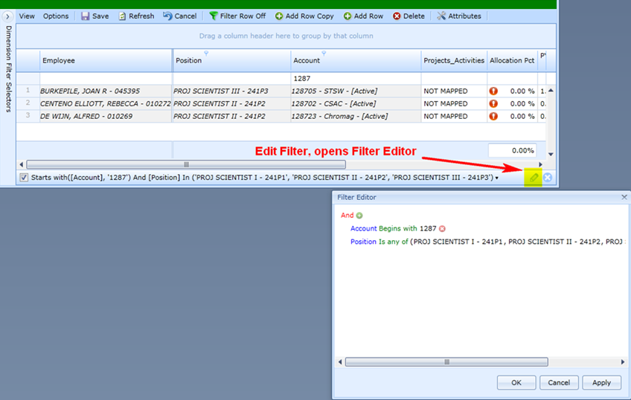

Clear / Delete the entire filter from the Menu Option:

