**Verify Mapped Funds against actual Planned Funds**

**Verify Employee Mapping for Salary Expenses**

From the Report Tab, open both the Allocation Mapping by Employee Report and the Employee Projections - Annual - Report

* Change the Dimension Filter selections on both grids as shown
* Name and Save the new Dimension Filters

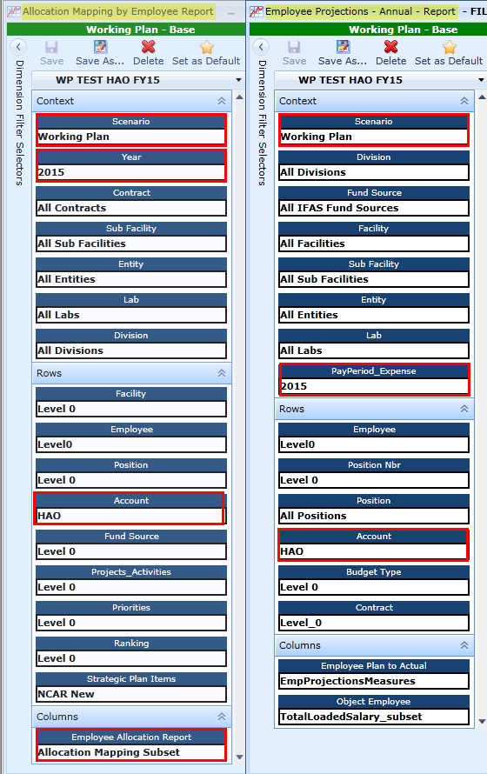

With only these two grids open, Allocation Mapping by Employee Report and Employee Projections -Annual - Report:

* Select the Window Tab, select Cascade
* Select the Windows Tab, select Tile Vertical to see the information side by side.
* Group each grid by Employee, moving the Employee Column Header to the Group Panel.
* Compare both the total at the bottom of the grids and individual employees. If there are discrepancies, you can expand the information for that employee.

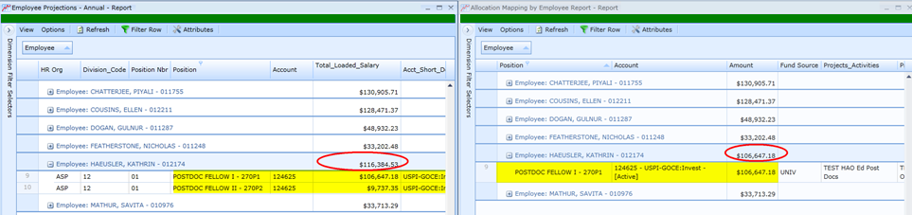

For discrepancies, open the Map Employee Accounts Data Entry Grid, filter for the Employee in question to view the information and make corrections as necessary. In this case the second key listed for this employee was not mapped.

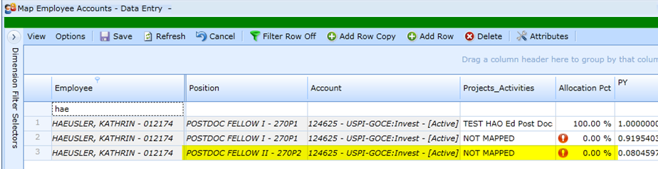

**Verify Account Mapping for All Expenses**

From the Report Tab, open both the Allocation Mapping by Account Report and the Budget Forecast Analysis - Annual - Report,

* Change the Dimension Filter selections for both grids as shown
* Name and Save the new Dimension Filters

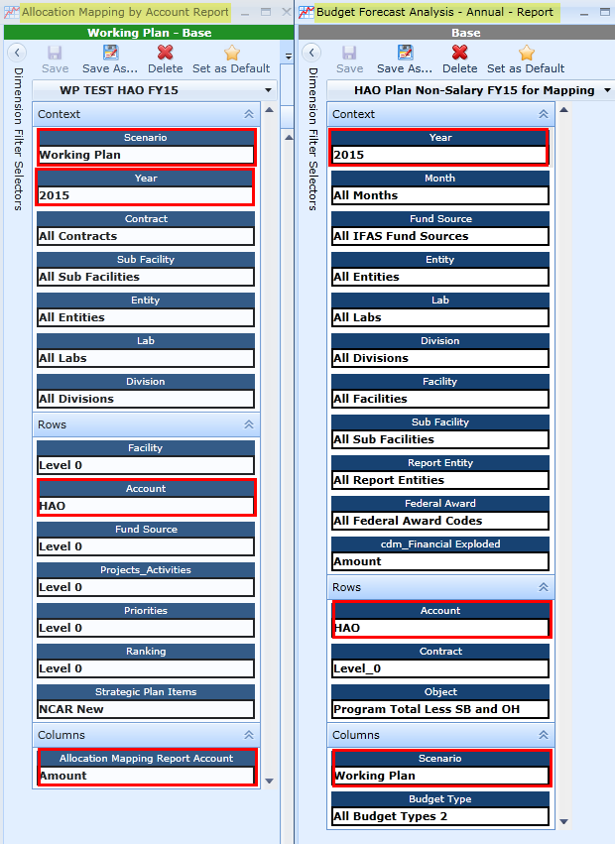

With only these two grids open, Allocation Mapping by Account Report and Budget Forecast Analysis - Annual - Report:

* Select the Window Tab, select Cascade
* Select the Windows Tab, select Tile Vertical to see the information side by side.
* Group each grid by Account, moving the Account Column Header to the Group Panel.
* Compare both the total at the bottom of the grids and individual Accounts.

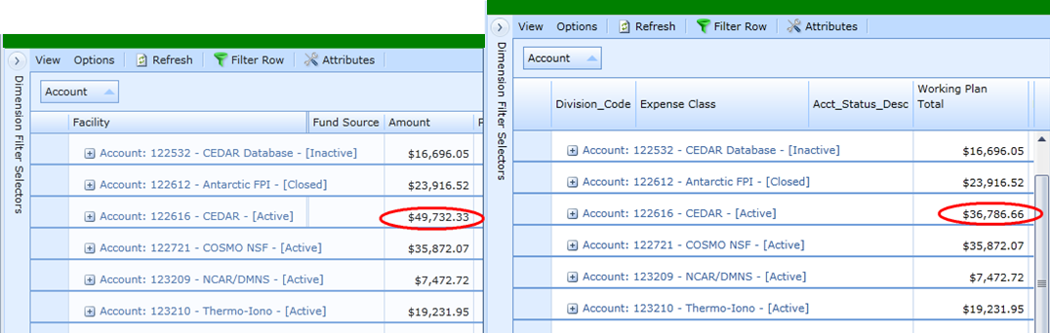

For discrepancies, since Employee Mapping has been verified, open the Map Non-Salary Data Entry Grid and look at the information in question and make corrections as necessary.