**Mapping Dimension Filters for Grids**

**Assign Projects / Activities to Priorities and Ranking Data Entry Grid**

* Change Dimension Filter selections where shown
* Name and Save the new Dimension Filter

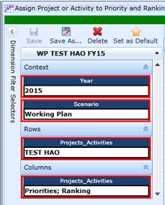

**Map Projects / Activities to Strategic Plan Items Data Entry Grid**

* Change Dimension Filter selections where shown
* Name and Save the new Dimension Filter

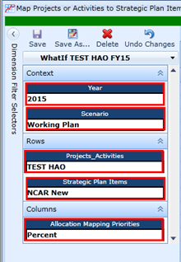

**Map Non-Salary to Project / Activities Data Entry Grid**

* Change Dimension Filter selections where shown
* Name and Save the New Dimension Filter

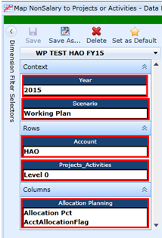

**Map Employee Salary Expenses to Projects / Activities Data Entry Grid**

* Change Dimension Filter selections where shown
* Name and Save the New Dimension Filter

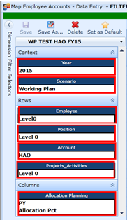

**Allocation Mapping by Employee Report Grid**

**Employee Projections Report Grid**

* Change the Dimension Filter selections on both grids where shown
* Name and Save the new Dimension Filters

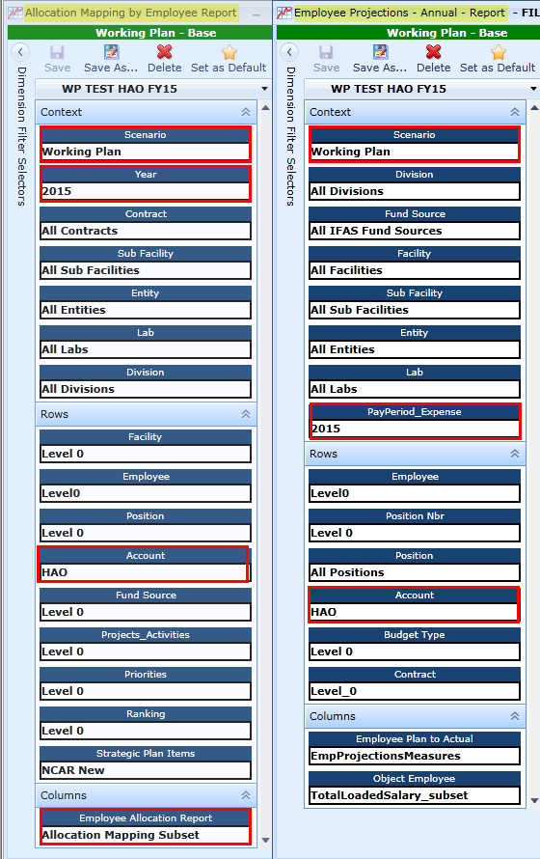

**Allocation Mapping by Account Report Grid**

**Budget Forecast Analysis Annual Report Grid**

* Change the Dimension Filter selections for both grids where shown
* Name and Save the new Dimension Filters

