**Mapping Process**

The main purpose of mapping is to facilitate the ABR process, allowing Labs to identify and rank priorities. It also simplifies answering questions from sponsors, providing a consistent tool, process and response throughout the organization and from year to year.

The Allocation Mapping Tool is one of the FAB Applications and includes the following Data Entry Grids and Report Grids:

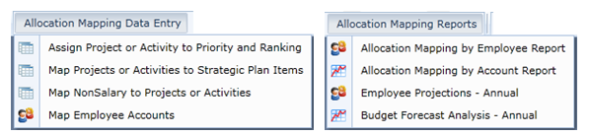

**Mapping Process**

*(Done within Working Plan Scenario or the What If Scenario for ABR, upon submission to B&P, copied to ABR Scenario)*

Preliminary Steps to identify Lab Strategic Plan items, Lab Priority items and Project / Activity items for mapping. (B&P adds this info to TM1)

1. Map Projects / Activities to Priorities and enter Ranking
2. Map Projects / Activities to Lab Strategic Plan Items
3. Map Planned Non-Salary expenses to Projects / Activities
4. Map Planned Employee Salary expenses to Projects / Activities
5. Verify Mapped Funds against actual Planned Funds

**Preliminary Steps – Create / Revise Lists for Lab Strategic Plan Items, Lab Priority Items and Project / Activity Items for the Fiscal Year.** (Labs create/edit lists and submit to B&P for uploading / supplementing information in TM1 for available lists and dropdowns in the Mapping Tool.)

**Lab Strategic Plan Items List**

* These should be at a high level from your Lab Strategic Plan and will be what you map your Projects / Activities to in the Mapping Tool. (Note: ASP and the NCAR Directorate will map to the NCAR strategic plan.)

**Lab Priority Items List – Optional**

* Priorities are optional and would typically be a shorter list, under which Lab Projects / Activities fall. In some cases these may be areas not specifically identified at a high level in your Strategic Plan, but areas where you anticipate questions from B&P, NSF or others. *NOTE: Rather than creating a longer list of Priorities, if all Projects / Activities names related to a topic include that name within the name, these can be rolled up with “contains” and that might provide an alternative to a longer list. Basically, you have less mapping work to do in not using Priorities for the distinction, but will need more intelligence in the Project / Activity names for sorting and grouping.*

**Project / Activity Items List**

* This would typically be the longest of the three lists.
* Items included should be in context of ABR Priorities / Tasks AND in context of your Lab Strategic Plan as well as the NCAR Strategic Plan.
* Items included should assist in responding to common questions about your program. (*NOTE: Some questions or issues are very specific and not necessarily ABR critical and might best be identified via User Defined Account Key attributes in FAB and not more detail added to your mapping Priorities and Projects / Activities.)*
* Priorities should be based on the Lab Strategic Plan
* Mega Tasks should be included project names

**Step 1 - Map Activities to Priorities and Enter Ranking - while priorities are optional, this grid must be completed for Reports to work. (If you have no priorities, see instructions below for simplified completion of this grid.)**

**Dimension Filters**

* Open the Grid “Assign Project or Activity to Priority and Ranking - Data Entry Grid”
* Change Dimension Filter selections as shown
* Name and Save the new Dimension Filter

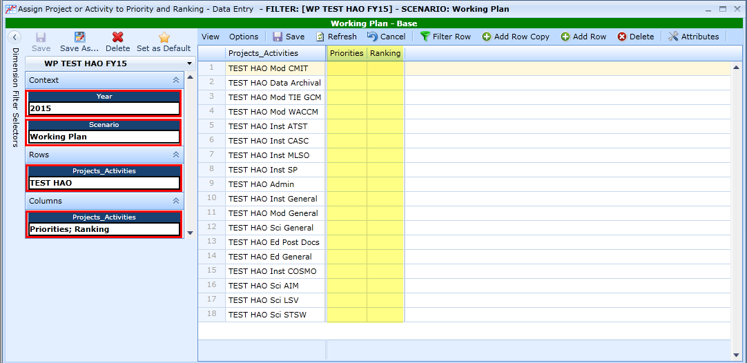

**Move or Drag the Ranking Column to the left of the Priorities Column**

The Ranking Column applies to Projects / Activities, not to Priorities, and users may find it easier to have the Ranking Column near Projects / Activities. 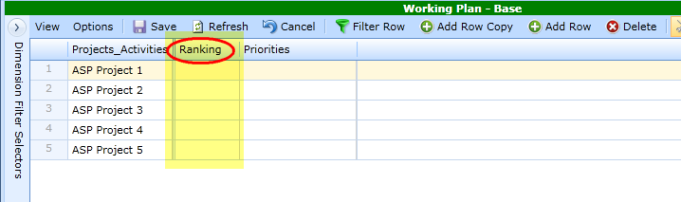

* Drag the Ranking Column to the left of the the Projects / Activities Column
* Select “View” “Save Grid Layout” to keep this format.

**Enter Priorities**

* Priorities are summary level and a Project / Activity can be mapped to only one Priority. **This step is necessary in order for expenses to come through on reports once those are mapped.** **Since Priorities are optional**, if you do not have Priorities, Select “Not Applicable” and copy to all cells.
* **Sorting / Filtering** – This is the key to simplifying data entry! Before entering Priorities, identify simple ways to sort or filter your Projects / Activities to enable easy copying and pasting to multiple lines. For instance, just sorting this example, if all “HAO Inst…” Projects / Activities fall under the same Priority; you can sort or filter to group those together, enter the priority once and copy it down.
* To enter a Priority, begin typing the appropriate Priority Name and select it from the Dropdown List, Utilizing Copy – Paste where applicable to simplify data entry.

**Enter Ranking**

* **Ranking applies to Projects / Activities**
* **Ranking is necessary for the report grids to work**. Rankings can be changed as you work on the ABR so your initial ranking assignment can be very general. Note you can rank all Project / Activities “1” or “100” or any other combination. You can put half your group in “1” and half in “2”…
* **Sorting / Filtering** - Before entering Rankings, identify simple ways to sort or filter your Priorities that would enable easy copying and pasting to multiple lines. If all Priorities fall under a similar Ranking, you can sort by Priority and copy the Ranking down to all lines in that Priority.
* To assign a ranking #, begin typing the number and select it from the Dropdown List, Utilizing Copy / Paste where applicable to simplify data entry.

**Verify Data Entry in this Grid**

* Sort to look for lines with no entry in Priorities or in Ranking

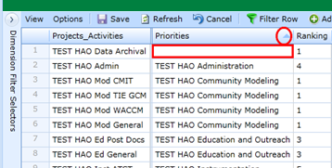

* Group by Priorities, right click on column name, select Full Expand and scan for accuracy
* Group by Ranking, right click on column name, select Full Expand and scan for accuracy

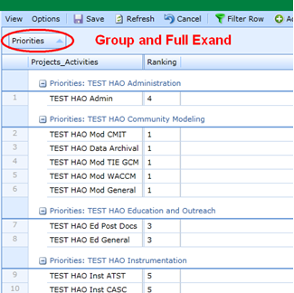

**Step 2 - Map Activities to NCAR Strategic Plan**

Each Project / Activity is listed with each Lab Strategic Plan Item to provide the option of mapping that Project / Activity to any applicable Strategic Plan Items. In this example, 18 Projects / Activities and 6 Strategic Plan Items result in 108 lines in this grid.

**Dimension Filters**

* Open the Grid “Map Projects or Activities for Strategic Plan Items – Data Entry”
* Change Dimension Filter selections as shown
* Name and Save the new Dimension Filter

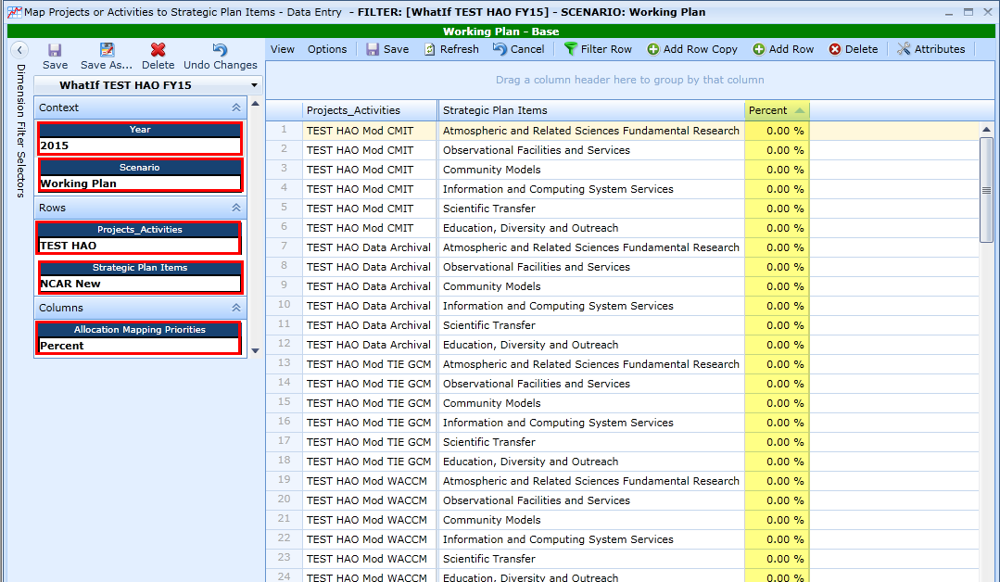

**Enter Percent**

* In this example, notice each Project / Activity is listed 6 times, with the option of mapping to all 6 of the Strategic Plan Items. The 18 Projects / Activities and 6 Strategic Plan Items result in 108 lines in this grid.
* **Sorting / Filtering** - Before entering percentages, identify where in the Strategic Plan Items your Projects / Activities Fall and where commonalities allow sorting or filtering to enable easy copying and pasting to multiple lines. The Filter Editor can be used to filter for all Projects_ Activities containing “MOD” tofilter on applicable Strategic Plan Item(s) “Community Models” to enter and copy the % down to all applicable rows.
* To enter Percent for a Strategic Plan Item utilizing sorting and filtering with Copy / Paste where applicable to simplify data entry.

**Verify Data Entry and Mapping Assignments in this Grid**

* Group by Projects Activities to verify projects are fully mapped – 100%:

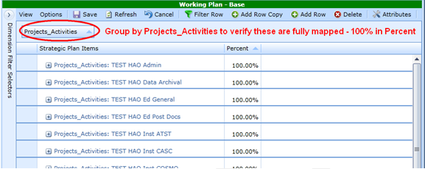

* While grouped by Projects / Activities:

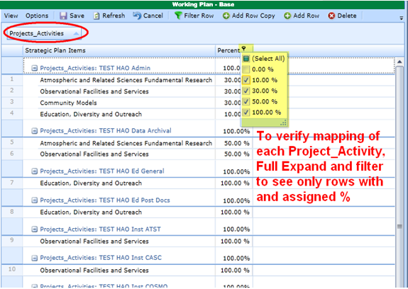

* + Right click on Projects / Activities to select Full Expand to see the detail.
  + Filter on Percent to exclude “0” to see how each Project / Activity has been assigned. *(In this example only 22 lines were mapped of the 108 possible combinations, so this makes it much easier to see and verify data entry.)*
* Group by Strategic Plan Items to verify projects were mapped correctly:

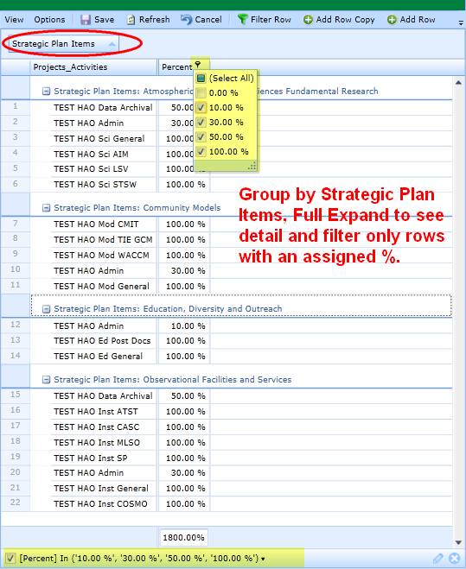

* + Right click on Strategic Plan Items and select Full Expand to see the detail.
  + Filter on Percent to exclude “0” to review and verify the mapping to the Strategic Plan.

**Step 3 - Map Planned Non-Salary Expenses to Project / Activities**

Each Account Key with planned non-salary expenses for the selected FY is listed. Upon opening the Grid all keys show up as “NOT MAPPED”. When you enter a Project / Activity in the NOT MAPPED line and save, the system creates a new record; there will be a line for the added item and the line for “NOT MAPPED” to allow additional data entry without Add Row Copy.

**Dimension Filters**

* Open the Grid “Map NonSalary to Projects or Activities - Data Entry Grid”
* Change Dimension Filter selections as shown
* Name and Save the New Dimension Filter

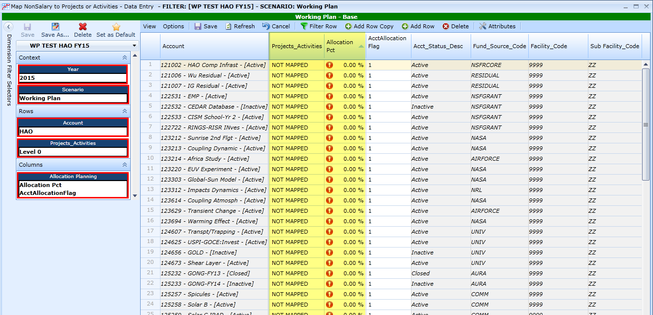

**Add Attributes to Grid**

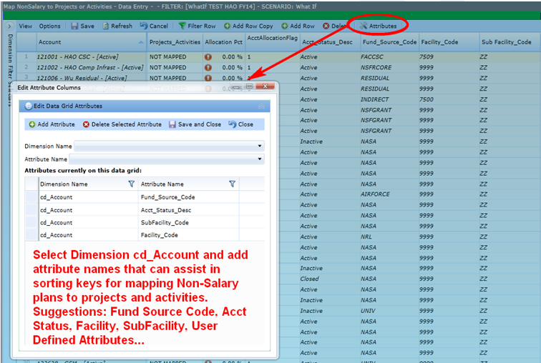

* Attributes such as fund source code, acct status, facility, Subfacility and user defined attributes may assist in sorting and filtering for data entry. Once these are added save with View, Save Grid Layout.

**Verify Keys Listed with Non-Salary Expenses**

* Under the Allocation Mapping Reports tab, Open the Budget Forecast Analysis Report and set the Dimensions as follows to see non-salary by key in the Working Plan for the given fiscal year. Name and Save the Dimension Filter. This allows you to compare information on the Non-Salary Mapping Data Entry grid with Non-Salary Information in your plan.

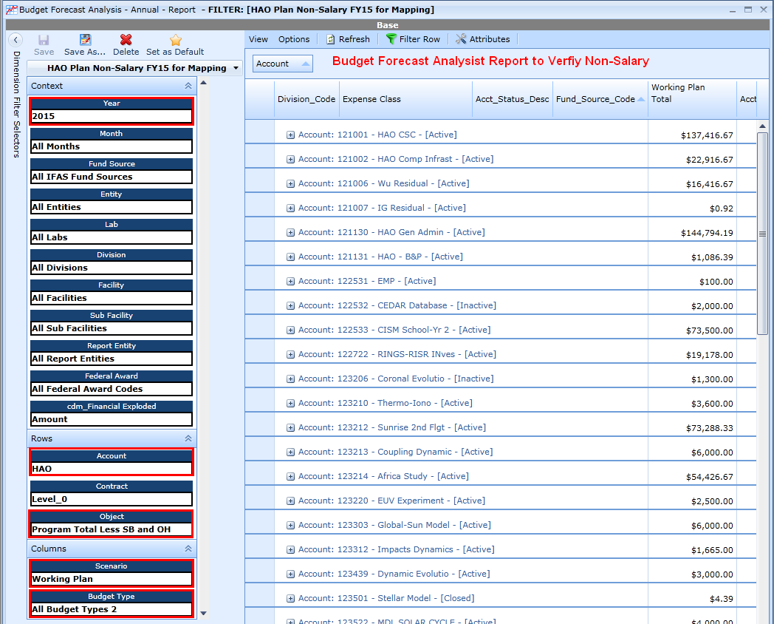

* With both grids open, select Window, Cascade and Window, Tile Vertical to see both grids and keys side by side to verify that keys listed for Mapping match Keys listed for Non-Salary.

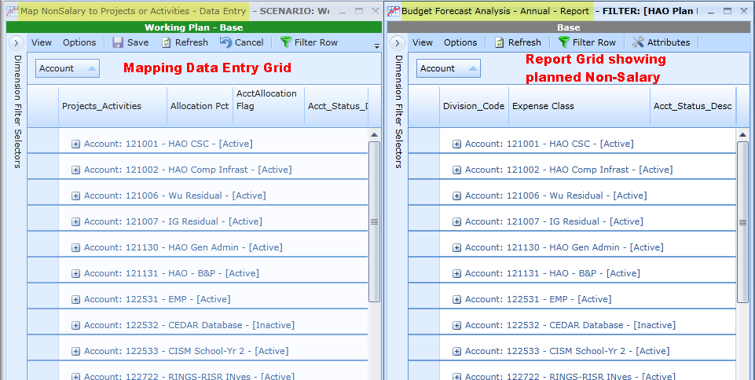

**Enter Projects / Activities and Allocation Percentages**

* **Sorting / Filtering** - Before entering Project / Activities and Allocation Percentages, identify any groupings or sorting for all keys associated with a specific Project / Activity that would to enable easy copying and pasting to multiple lines. If certain keys should be mapped similarly, you can select only those keys and enter and copy entries for those keys. It may also be helpful to sort or group by Fund Source, Acct Manager, User Defined Attributes or Facility Code. **Typically on this grid mapping keys with Non-Salary Expenses and your filtering will be key based.**
* Mapping
  + Generally the assumption is that non salary keys are mapped to one Project / Activity, but these can be mapped to multiple Projects / Activities.
  + Sort or filter to obtain keys associated with a single Project / Activity with a common percentages
  + Begin to enter the Project Activity Name to select it from the drop down list
  + Enter the Percentage allocated to that Project Activity.
  + Utilize Copy / Paste where applicable to simplify data entry.

**Verify Data Entry and Mapping Assignments in this Grid**

* Filter on “Allocation Pct” selecting on 0.00%.

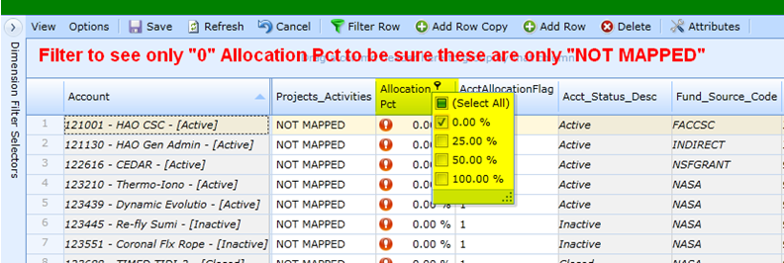

* + Verify that there are no Projects / Activities incomplete with 0% allocation.
  + Verify only “NOT MAPPED” should have 0% allocation.
  + Verify that all “NOT MAPPED” entries show only 0% allocations.
* Group by Account to verify projects are fully mapped – 100%.

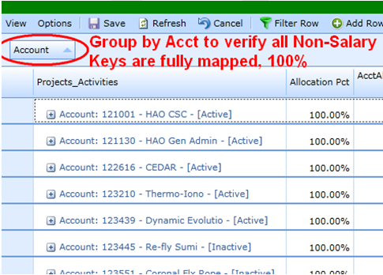

* While grouped by Account:

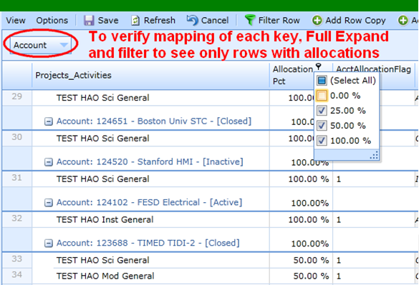

* + Right click on “Account” to select Full Expand to see the detail
  + Filter on Allocation % to exclude “0” to see how each key has been mapped.
  + Check to see that each account is mapped to the appropriate Projects / Activities and at the appropriate Allocation %.
* Group by Projects / Activities to see how keys and % are assigned to a particular activity

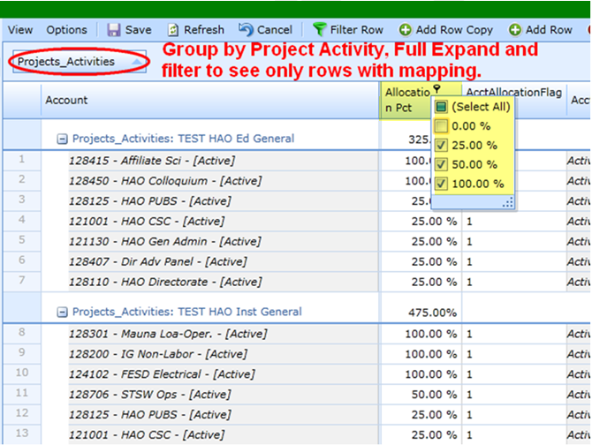

* + Right click on Projects / Activities and select Full Expand to see the detail
  + Filter on Allocation % to exclude “0” to review and verify the mapping of keys to Projects / Activities.

**Step 4 - Map Planned Employee Salary Expenses to Projects / Activities**

Each employee is listed with each planned instance on a key. In this example, 54 employees listed on each instance of each key, result in 295 lines in this grid.

Upon opening the Grid all keys show up as “NOT MAPPED”. When you enter a Project / Activity in the NOT MAPPED line and save, the system creates a new record; there will be a line for the added item and the line for “NOT MAPPED” to allow additional data entry without Add Row Copy.

**Dimension Filters**

* Open the Grid “Map Employee Accounts Data Entry Grid”
* Change Dimension Filter selections as shown
* Name and Save the New Dimension Filter

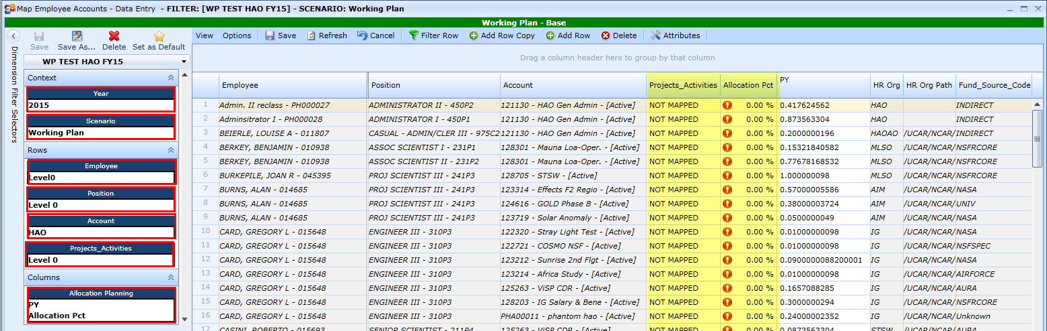

**Add Attributes to Grid**

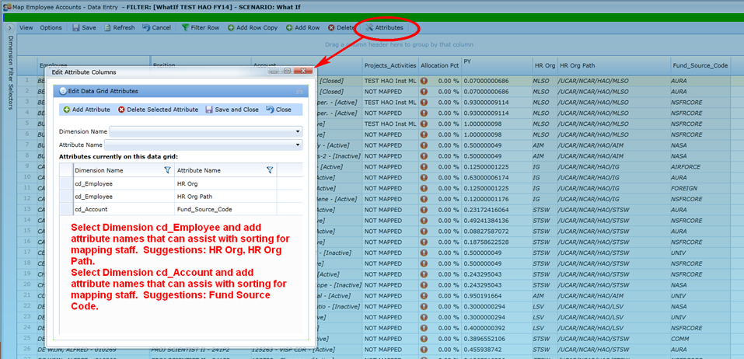

* Attributes such as fund source code, HR Org and HR Org Path may assist in sorting and filtering for data entry. Once these are added save with View, Save Grid Layout to retain the attributes in the grid.

**Enter Projects / Activities and Allocation Percentages**

* **Sorting / Filtering** - Before entering Project / Activities and Allocation Percentages, identify any groupings or sorting that would identify all Employees associated with specific Projects / Activities and Allocation %’s that would enable easy copying and pasting to multiple lines. For example all employees in one group or HR Org may be assigned 80% to one Project / Activity and 20% to a second or all employees with on job title may be associated with one Priority / Activity. **On this grid, mapping employee AND keys with Non-Salary Expenses, filtering and sorting can take place in several areas - HROrg, HROrg Path, Facility, Subfacility, Account Key, Position Title/ Employee or Fund Source.**
* Mapping
  + Employees are mapped 100% to each key to which they are assigned

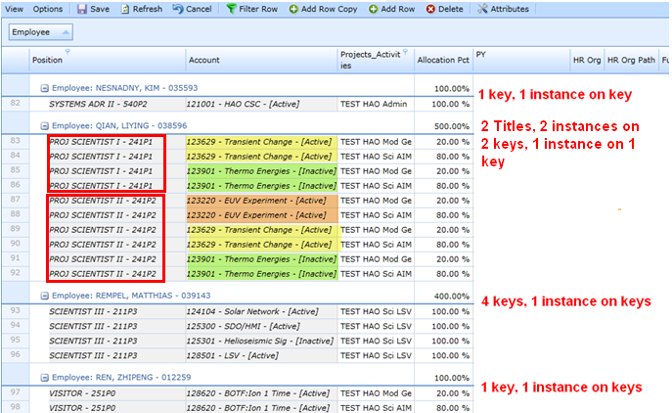

* + Sort or filter to obtain Staff and keys associated with a single Project / Activity with a common percentages
  + Begin to enter the Project Activity Name to select it from the drop down list
  + Enter the Percentage allocated to that Project Activity.
  + Utilize Copy / Paste where applicable to simplify data entry.

**Verify Data Entry and Mapping Assignments in this Grid**

* Filter on “Allocation Pct” selecting on 0.00%

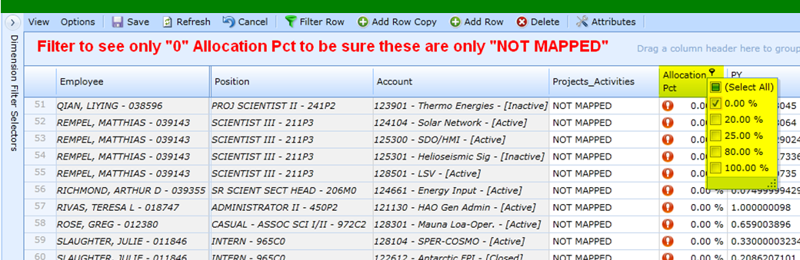

* + Verify that there are no Account Keys incomplete with 0% allocation.
  + Verify only “NOT MAPPED” should have 0% allocation.
  + Verify all “NOT MAPPED” entries show only 0% allocations.
* Group by Employee and by Acct to verify employees are fully mapped. Filter on Allocation Pct to exclude “0” to easily see how each person is mapped.

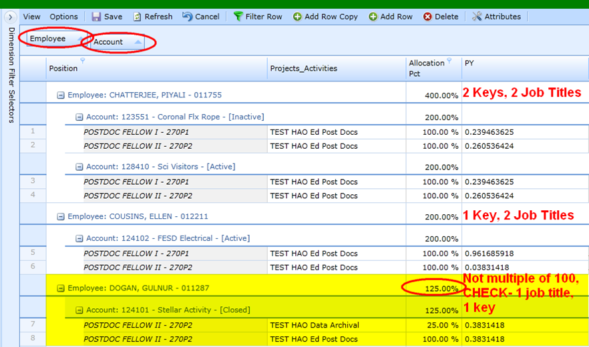

* + Check any individual by expanding to see employee and acct detail.
  + Anyone at 0.00% is not mapped
  + All employee mapping should be 100% or multiples of 100 because all keys are mapped to 100%
  + 200% - OK if one key, two instance on each key, 1x2
  + 400% - OK if two keys, two instances on each key. 1x2 + 1x2
  + 500% - OK if one key, one instance, two keys two instances on each key , 1x1 + 1x2 + 1x2
  + Each Key should be mapped at 100% unless there are multiple instances on the key, but should still be in multiples of 100, 100% * number of instances.
* Group by Projects / Activities to see who has been mapped to a project and the % that are assigned.

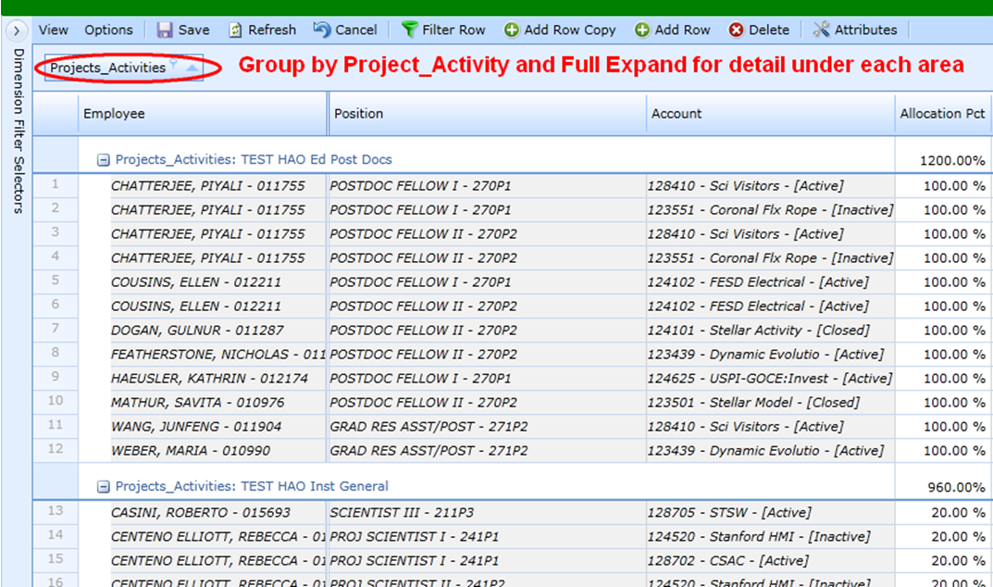

* + Right click on Projects / Activities and select Full Expand to see the detail to determine if someone is mapped in the wrong area or perhaps at the wrong percentage.

**Step 5 - Verify Mapped Funds against actual Planned Funds**

**Verify Employee Mapping for Salary Expenses**

From the Report Tab, open both the Allocation Mapping by Employee Report and the Employee Projections - Annual - Report

* Change the Dimension Filter selections on both grids as shown
* Name and Save the new Dimension Filters

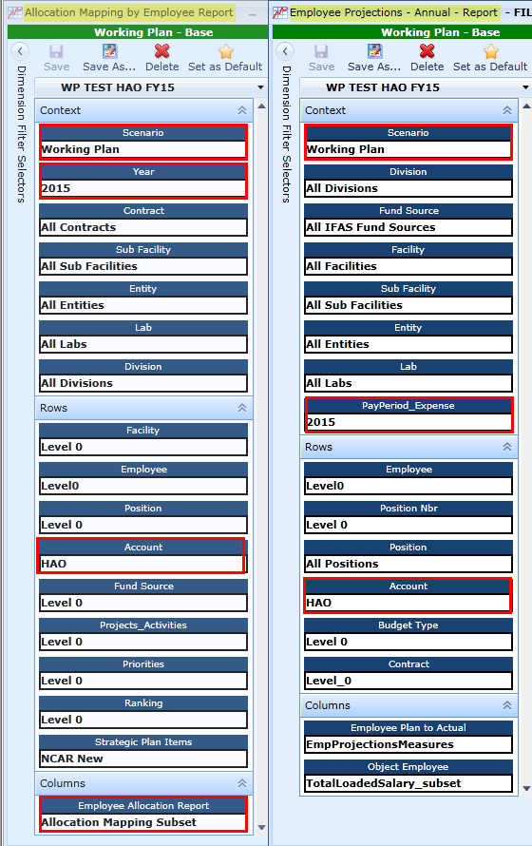

With only these two grids open, Allocation Mapping by Employee Report and Employee Projections -Annual - Report:

* Select the Window Tab, select Cascade
* Select the Windows Tab, select Tile Vertical to see the information side by side.
* Group each grid by Employee, moving the Employee Column Header to the Group Panel.
* Compare both the total at the bottom of the grids and individual employees. If there are discrepancies, you can expand the information for that employee.

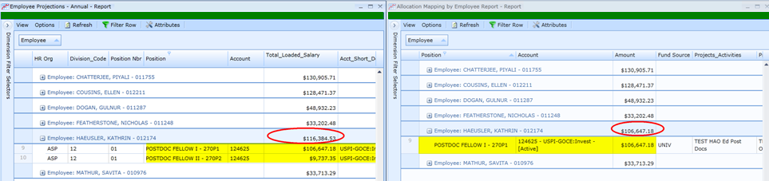

For discrepancies, open the Map Employee Accounts Data Entry Grid, filter for the Employee in question to view the information and make corrections as necessary. In this case the second key listed for this employee was not mapped.

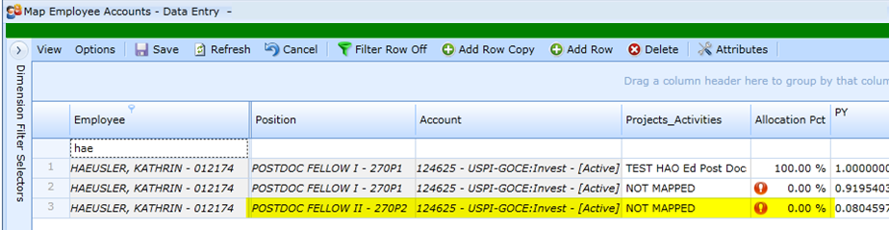

**Verify Account Mapping for All Expenses**

From the Report Tab, open both the Allocation Mapping by Account Report and the Budget Forecast Analysis - Annual - Report,

* Change the Dimension Filter selections for both grids as shown
* Name and Save the new Dimension Filters

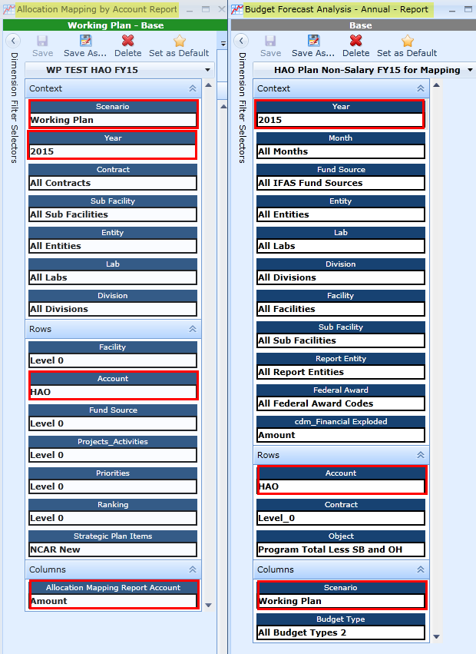

With only these two grids open, Allocation Mapping by Account Report and Budget Forecast Analysis - Annual - Report:

* Select the Window Tab, select Cascade
* Select the Windows Tab, select Tile Vertical to see the information side by side.
* Group each grid by Account, moving the Account Column Header to the Group Panel.
* Compare both the total at the bottom of the grids and individual Accounts.

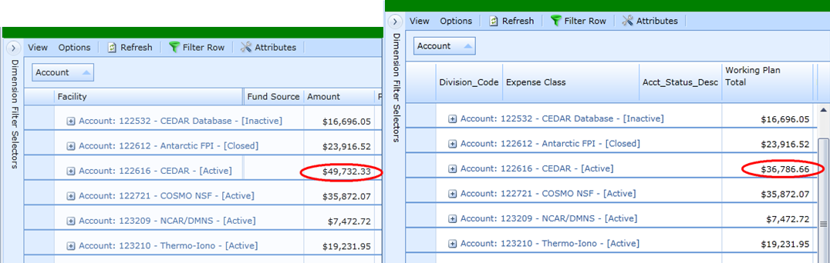

For discrepancies, since Employee Mapping has been verified, open the Map Non-Salary Data Entry Grid and look at the information in question and make corrections as necessary.

**Submission to B&P as part of ABR Process**

Per ABR guidance, submit your FY16 ABR materials to B&P. The copying final process is TBD, but it will be such that your Working Plan, which matches your ABR submission, will be copied to the ABR Scenario and the mapping for Working Plan will be copied to mapping for ABR Scenario at that time as well.